*COFE DISTRICT*

DEtailed Functional Documentation

Version 1.0

09/06/2017

Prepared By:

FISAL HASSAN

VERSION HISTORY

|  |  |  |  |  |  |
| --- | --- | --- | --- | --- | --- |
| **Version #** | **Implemented**  **By** | **Revision**  **Date** | **Approved**  **By** | **Approval**  **Date** | **Reason** |
| 1.0 | Fisal Hassan | *09/06/2017* |  |  | Initial Documentation |

TABLE OF CONTENTS

ProJect Documentation Approval 97

1. Introduction 4

Purpose of The detailed Specification Document 4

PROJECT OVERVIEW 4

2. Scope Of Work 5

3. Website Structure 8

4. Administration Section 47

5. COMMON FUNCTIONALITIES 95

1. Introduction

## Purpose of The detailed Specification Document

This document provides a comprehensive and detailed architectural overview of the system design in order to give the development team guidance on architecture of the system to be developed. Its intended audience is the Business Sponsors, Project manager, project team and development team. Some portions of this document such as the user interface (UI) may on occasion be shared with the client/user, and other stakeholder whose input/approval into the UI is needed.

## PROJECT OVERVIEW

**Project title**

Deera Coffee – Food Online Order & Interactive Delivery

**Terminology**

* MAWAQAA – National Web Solutions Company
* UI/GUI – User Interface/Graphical User Interface. Portion of the product where the user sees and interacts with.
* UX – User Experience
* QA – Quality Assurance. A planned and systematic process necessary to provide adequate confidence that the product optimally fulfils customer expectations
* Admin – Administrator/Administrator Section
* Project Owner – Mawaqaa Client or an authorized representative
* Development Change – Not Covered under Current Scope

1. Scope Of Work

The Scope of work will be covering Food Online Order & Interactive Delivery Website for Deera Coffee. The website will be available in English and Arabic.

The Following are the functionality for Food Online Order & Interactive Delivery Website

* Design & build a world class Internet portal for ecommerce application.
* Develop an intuitive website architecture that includes easy to use navigation, site structure, colour schemes, user experience, site usability and interactive features.
* There will be the below User roles
  + Super Admin (Deera Coffee Admin)
    - This user will have access over the whole system
    - Deera’s Admin receives orders from a specific Coffee Shop or the Coffee Shop related branches
  + Coffee Shop’s Admin
    - This user will be the admin for Coffee Shop. One Coffee Shop admin can be added to multiple Coffee Shops.

Deera’s Admin check the available drivers who can deliver the order.

Deera’s Admin assign the order for the one of the available drivers.

When a driver accepts to deliver the order, then admin can start monitoring the delivery process.

The logged in users can view the full details of his/her own order , which contains the order details and driver details.

The guest users will receive only the order details.

The driver should notify the concerned admin of the time for the following phases.

* + - * When the driver accept the order.
      * When the driver be near of the customer.
      * When the driver delivered the order.

In all of these phases the customers will receive a notification.Especially the driver is 2 minutes far from the target address and once the driver is arrived at the door.

If the driver delayed to deliver the order, then the driver will send a notification for the concerned admin by using a mobile app.

If the driver delayed to retuned back to the Coffee Shop, the driver will send a notification for the concerned admin

The admin will get a notifications on his own dashboard.

1. admin

admin receives service requests from Deera Coffee or Coffee Shops and Coffee Shop branches

If the driver faced any issues when he/she is going to deliver the order like (flat tire, accident)

Or any other reasons, he/she notify the concerned admin.

admin will re-check another available driver to continue the delivery process.

* + Driver
    - These users are for delivering the orders of customers from the specific Coffee Shops.
    - There will be lists of drivers for Coffee Shops and also for Deera Coffee.
  + Customer
    - Registered users from website and mobile applications, who will order and buy foods from different Coffee Shops.

Details will be explained in later sections of the document.

1. Website Structure

The following listed are the approved components for website structure for Deera Coffee Capital.

**Deera Coffee Website Structure**

* Home page - الصفحة الرئيسية

1. Welcome Pop up/Advertisement Pop up //Once closed enter the website
2. Header
   1. Logo
   2. Login //Pop up

2.2.1 Signup Page //Forgot password, Remember me

* 1. My Account
     1. My Orders
     2. My Profile
     3. Saved Addresses
     4. Logout
  2. Arabic/English
  3. My Cart

1. Banner Section
   1. Search by Location
      1. Search Page with Search by location and Coffee Shop and List of All Coffee Shops //The top icon will reflect the selected location
      2. Menu page with Categories, General Information, ratings & Products //If the Shop is closed, user will not be able to order now but can schedule.
      3. Product Description page //Size is required.
      4. My Cart Page //Delivery Fees can be changed from CMS
      5. Checkout Page // Login/Register, Order Summary, Delivery Address, time & Payment Gateway – Order now or Schedule(per day or range) pop up
2. About us
   1. About us info
   2. Delivery<30 mins
   3. No minimum orders
   4. Fixed Delivery Cost
3. Order flow steps
4. Advertisement Banners (1 Main and 3 Sub)
   1. Main Banner – Slideshow
   2. 2 Sub ads
   3. Add your Coffee shop form pop up
5. Footer
   1. Browse
      1. Home
      2. About us //Content, Video & Images
      3. Careers
      4. Media
      5. Cofe Blog //Search Bar with Blogger or date, with Become Blogger option(Pop up form) and list of Blogs.
         1. Cofe Blog article with Image //Share on social media
      6. Contact us
   2. Orders
      1. My Profile
      2. My Orders //Receipt will be printed by the Coffee Shop & Users will have it
         1. Current Orders
         2. Completed Orders //Users can reorder
      3. Order Summary //Track Order
      4. FAQs //Questions & Answers
      5. Privacy Policy
         1. Profiles
         2. Security
      6. Terms & Conditions
         1. Order Cancellations
         2. Licenses
   3. Cofe Club
      1. My Gift cards //List of Gift cards with Order summary & Payment gateway
         1. Gift Cards // Gift card with Send to friend form pop up & View Receipt
      2. Offers // Linked to the Coffee Shop Offers tab
      3. Catering //Form which will ask for Customer details, saved in cms
   4. Contact // Phone and Email
   5. Download Android & IOS icons
   6. Copyright info
   7. Social Media icons
      1. Facebook
      2. Twitter
      3. Linkedin
      4. Youtube

Instagram

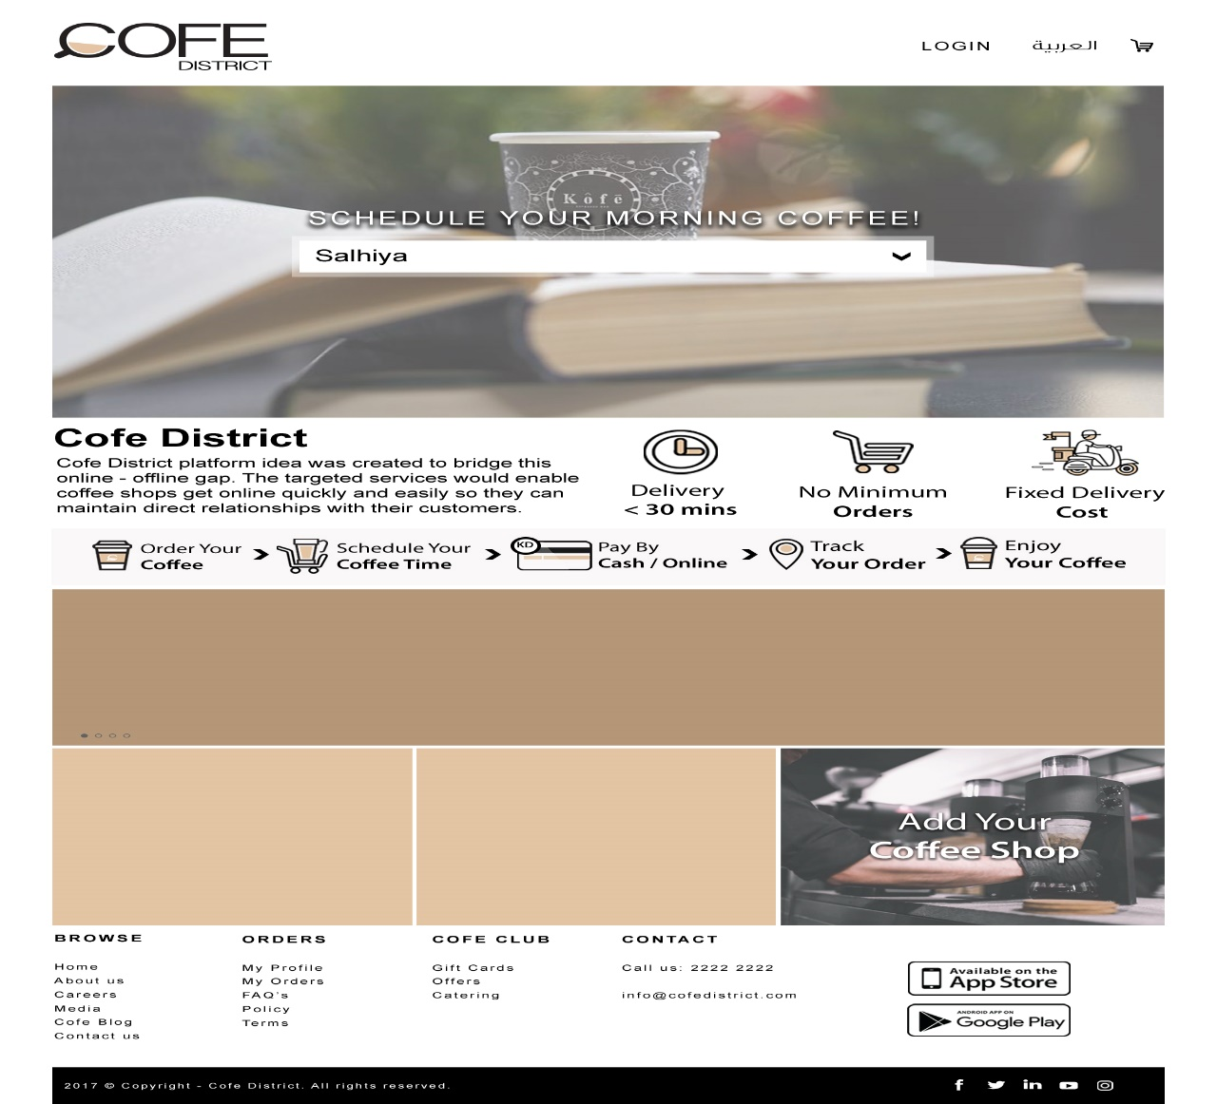

* Header Area

**Header Contains:**

* Company Logo & name (left corner )
* Login link
* “Arabic /Eng.” link to switch between User interface (Arabic or English)
* My Cart
* Footer Area

**Footer Contains:**

1. Available Payment Methods ( Description & Links)
   * Cash on delivery , KNet , Visa /Master
2. Mobile Application links( Description & Links)
   * Android (Google Play), IOS
3. Social Links
   * Facebook ,Twitter , YouTube, Instagram, Linkedin
4. Static Links ( in all inner pages)
   * About us, Add Coffee Shop, Feedback, Terms, FAQs (static page- have fixed questions), Privacy, Sitemap.

5- Cofe Club

5.1. My Gift cards //List of Gift cards with Order summary & Payment gateway

5.1.1Gift Cards // Gift card with Send to friend form pop up & View Receipt

5.2. Offers // Linked to the Coffee Shop Offers tab

5.3. Catering //Form which will ask for Customer details, saved in cms

* Coffee Shops - المطاعم

List all Coffee Shops /Kitchens and brief description on it

Number should be displayed

* + Transactions Guide دليل المعاملات -

// to be integrated with CMS

// this will show text

//a drop down menu will be shown after intro; whenever one of the drop-down-menu items, a table with details

* + Website Services Guide دليل خدمات الموقع -

// to be integrated with CMS

// by default listing page will appear to show all services titles.

// if user clicked on any of the titles, an accordion effect will expand to show details and images

* Search Coffee Shops –بحث عن المطاعم

List all Coffee Shops /Kitchens and brief description on it

* + Transactions Guide دليل المعاملات -

// to be integrated with CMS

// this will show text

//a drop down menu will be shown after intro; whenever one of the drop-down-menu items, a table with details

* + Website Services Guide دليل خدمات الموقع -

// to be integrated with CMS

// by default listing page will appear to show all services titles.

// if user clicked on any of the titles, an accordion effect will expand to show details and images

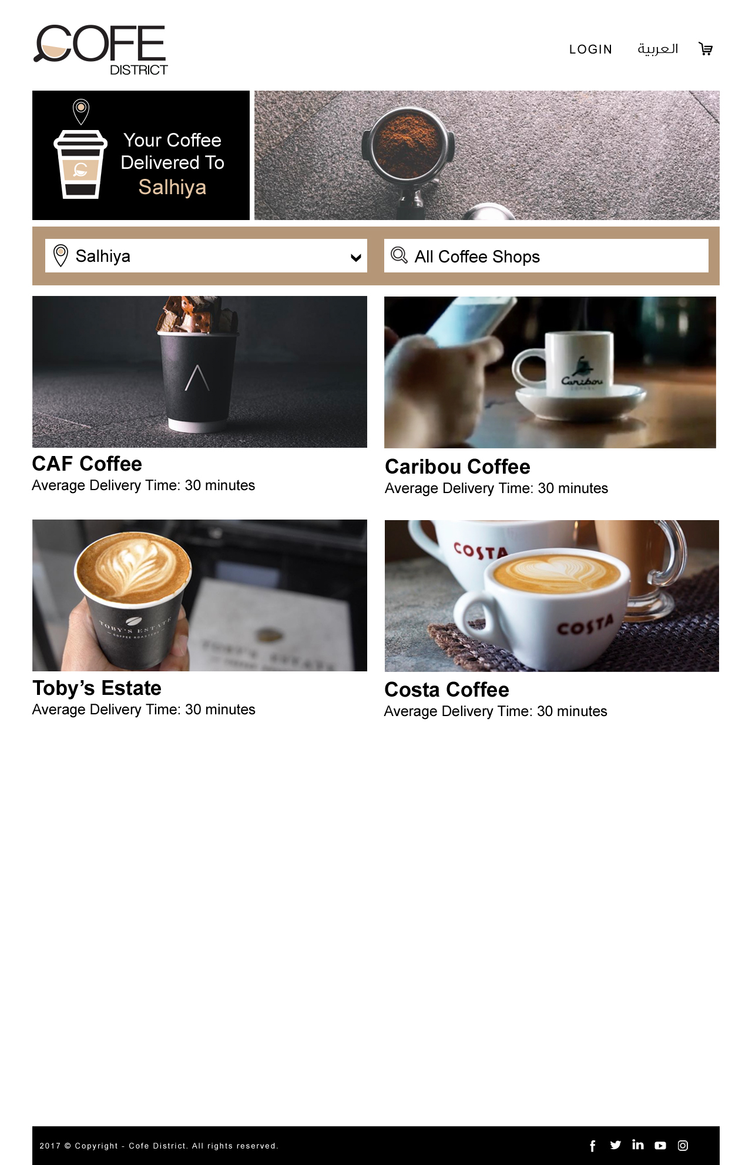

* Login تسجيل الدخول –
  + Administration الإدارة – ( this will be redirecting administrator screen)
  + Users – المستخدمين ( this will be redirecting users to a login screen)

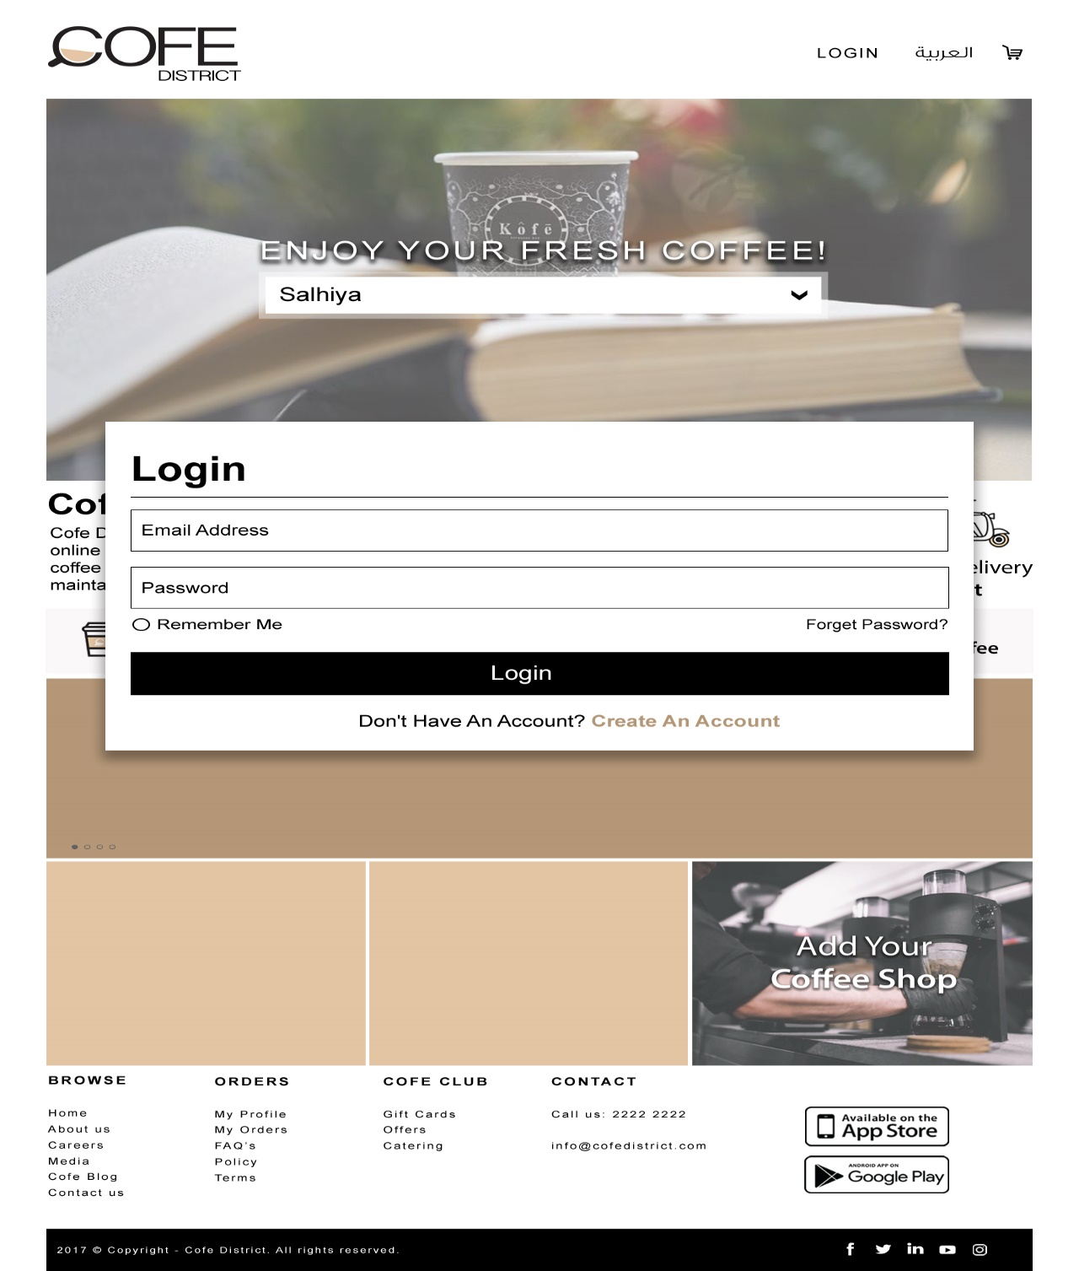

* Signup

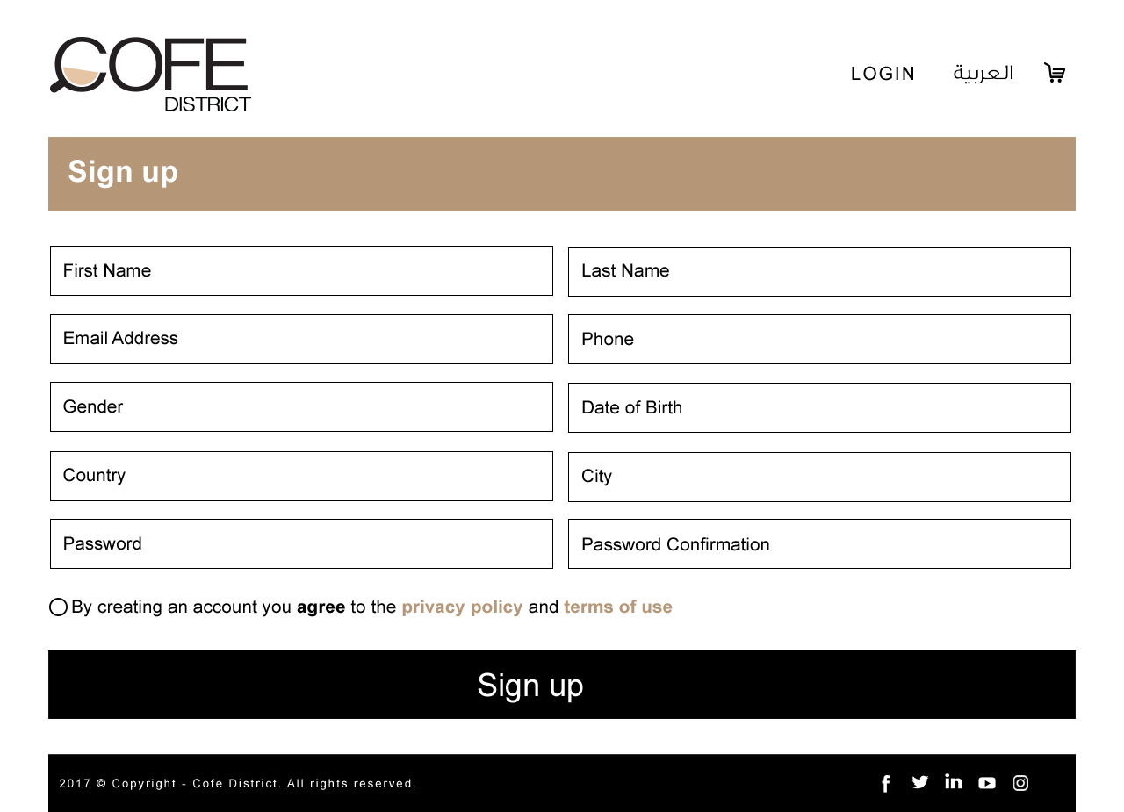

* About Us نبذة عنا -
  + About Company نبذة عن الشركة - // text only, page will be static page(edit by administrator),
  + Vision & Mission رؤيتنا و رسالتنا - // text only

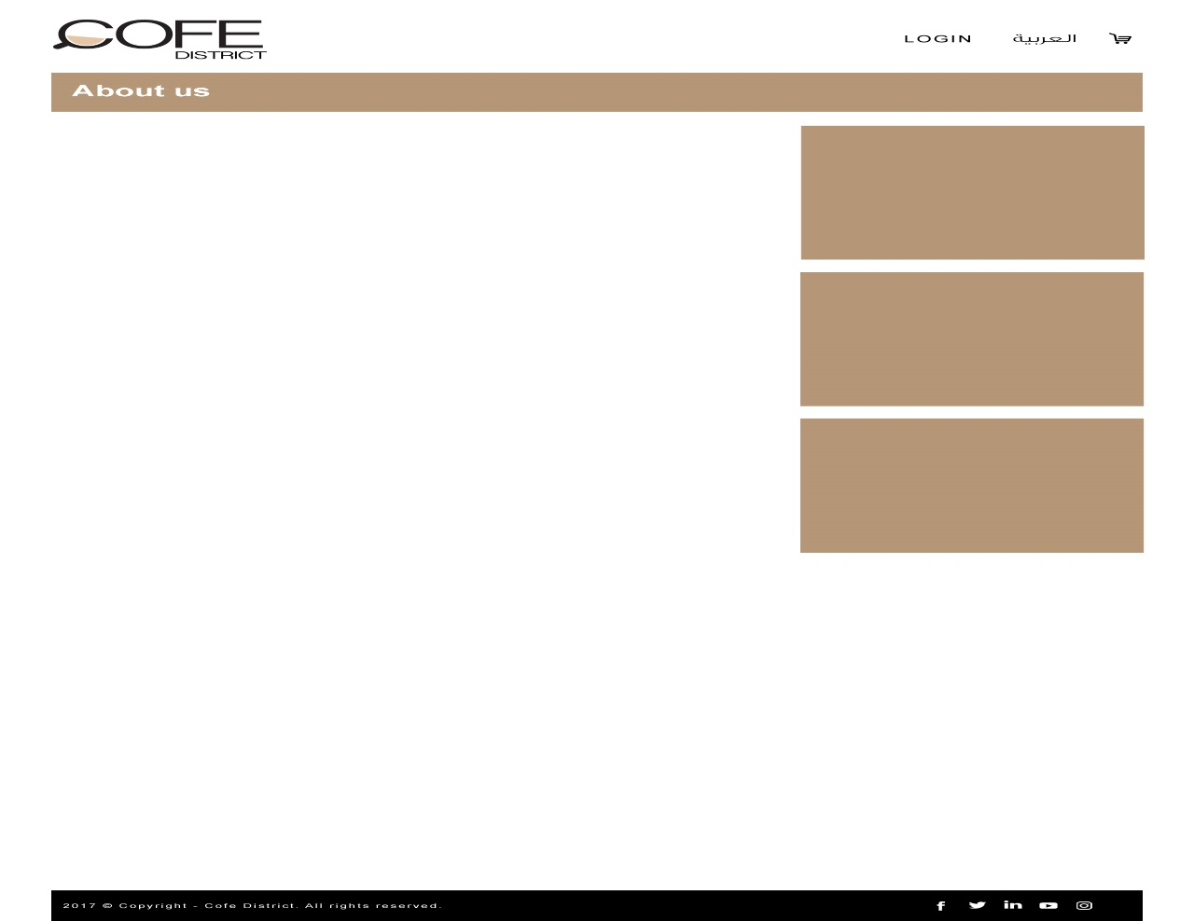

* Careers

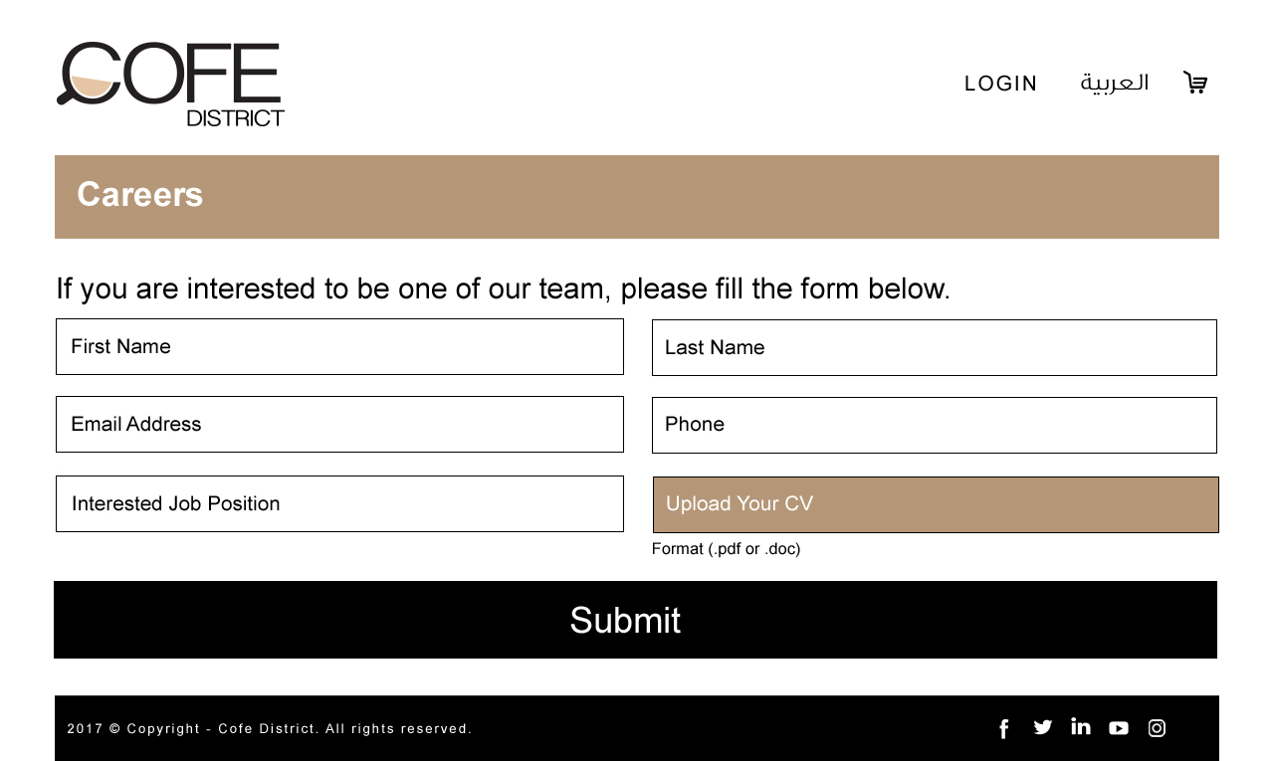

* Media

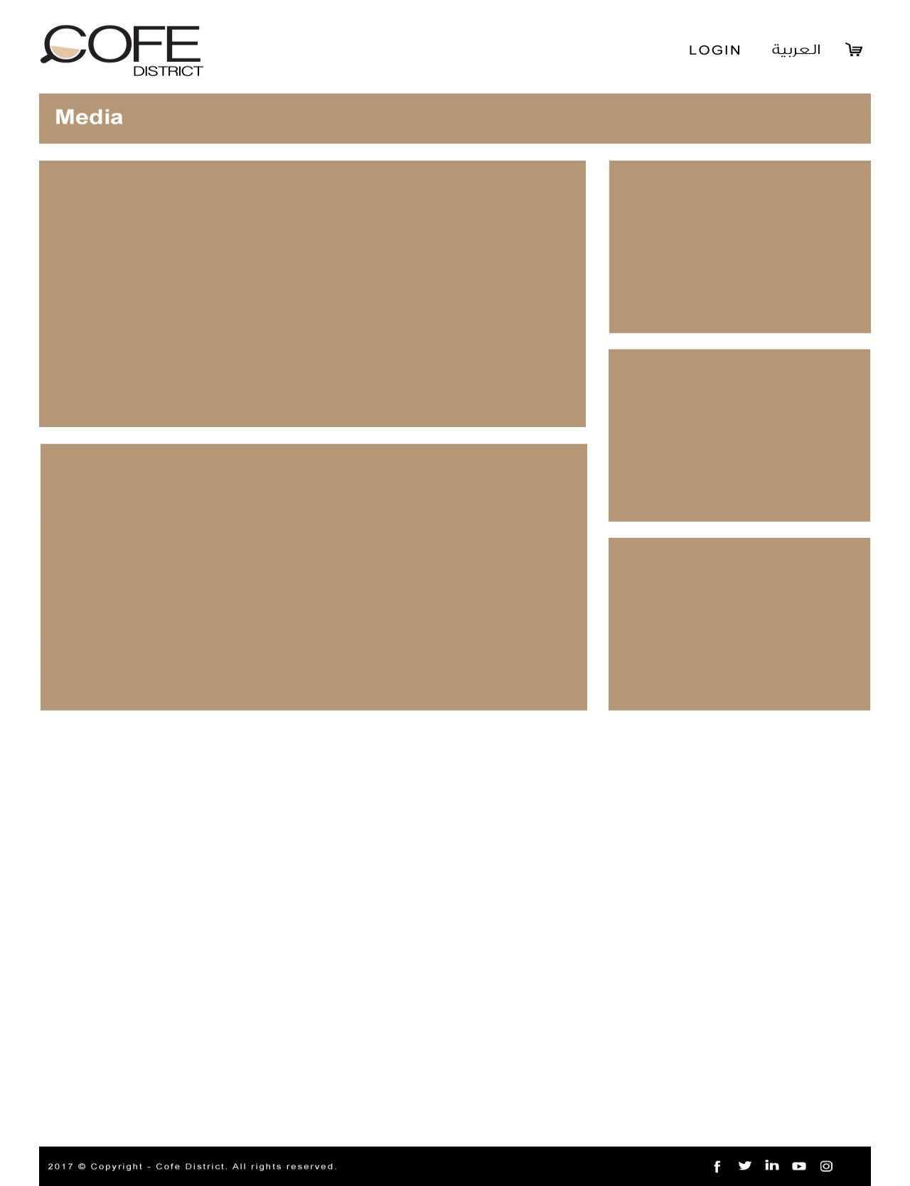

* Cofe Blog

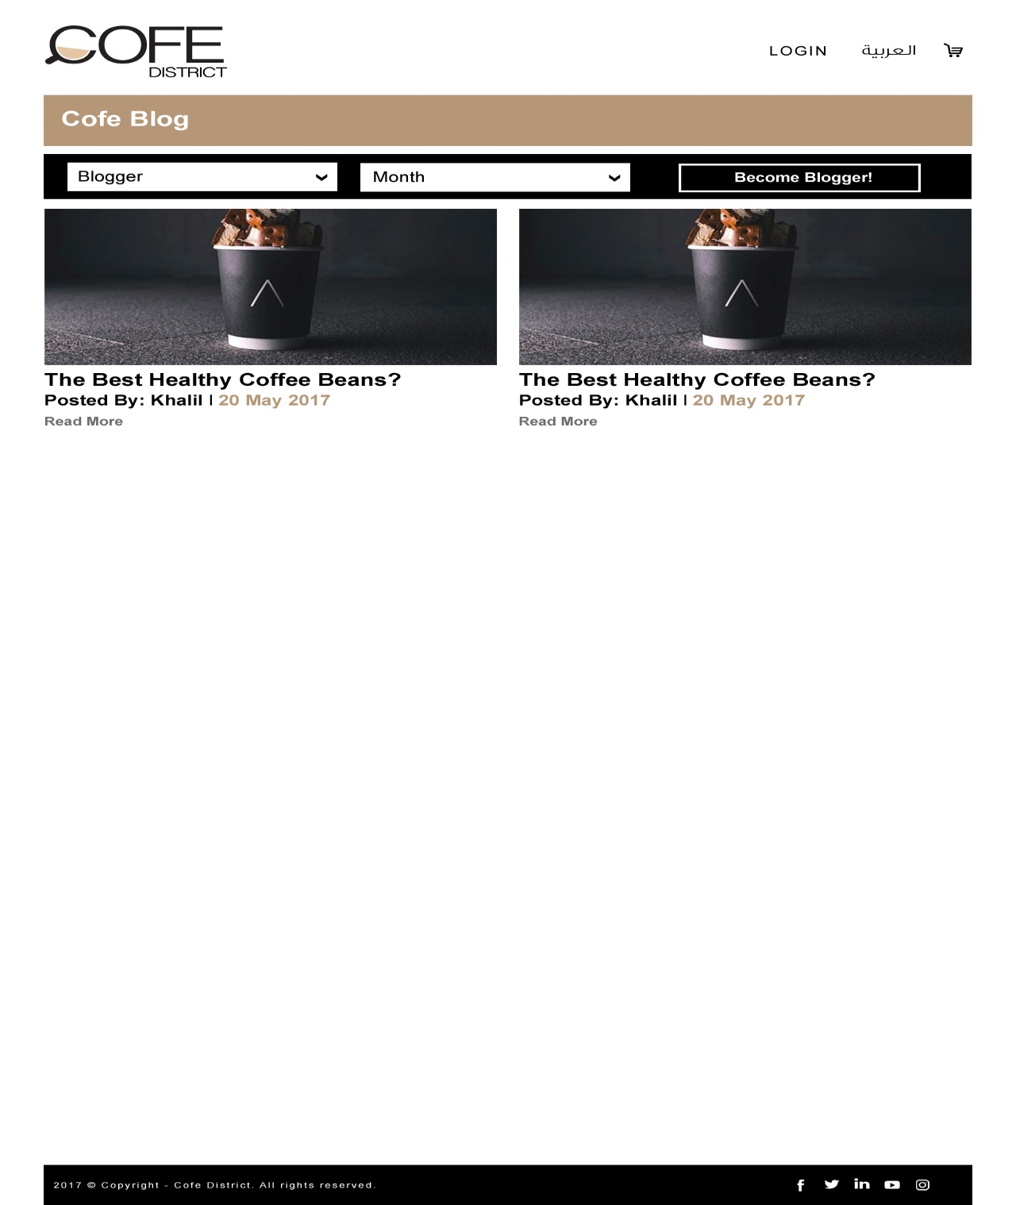

* The Best Coffee

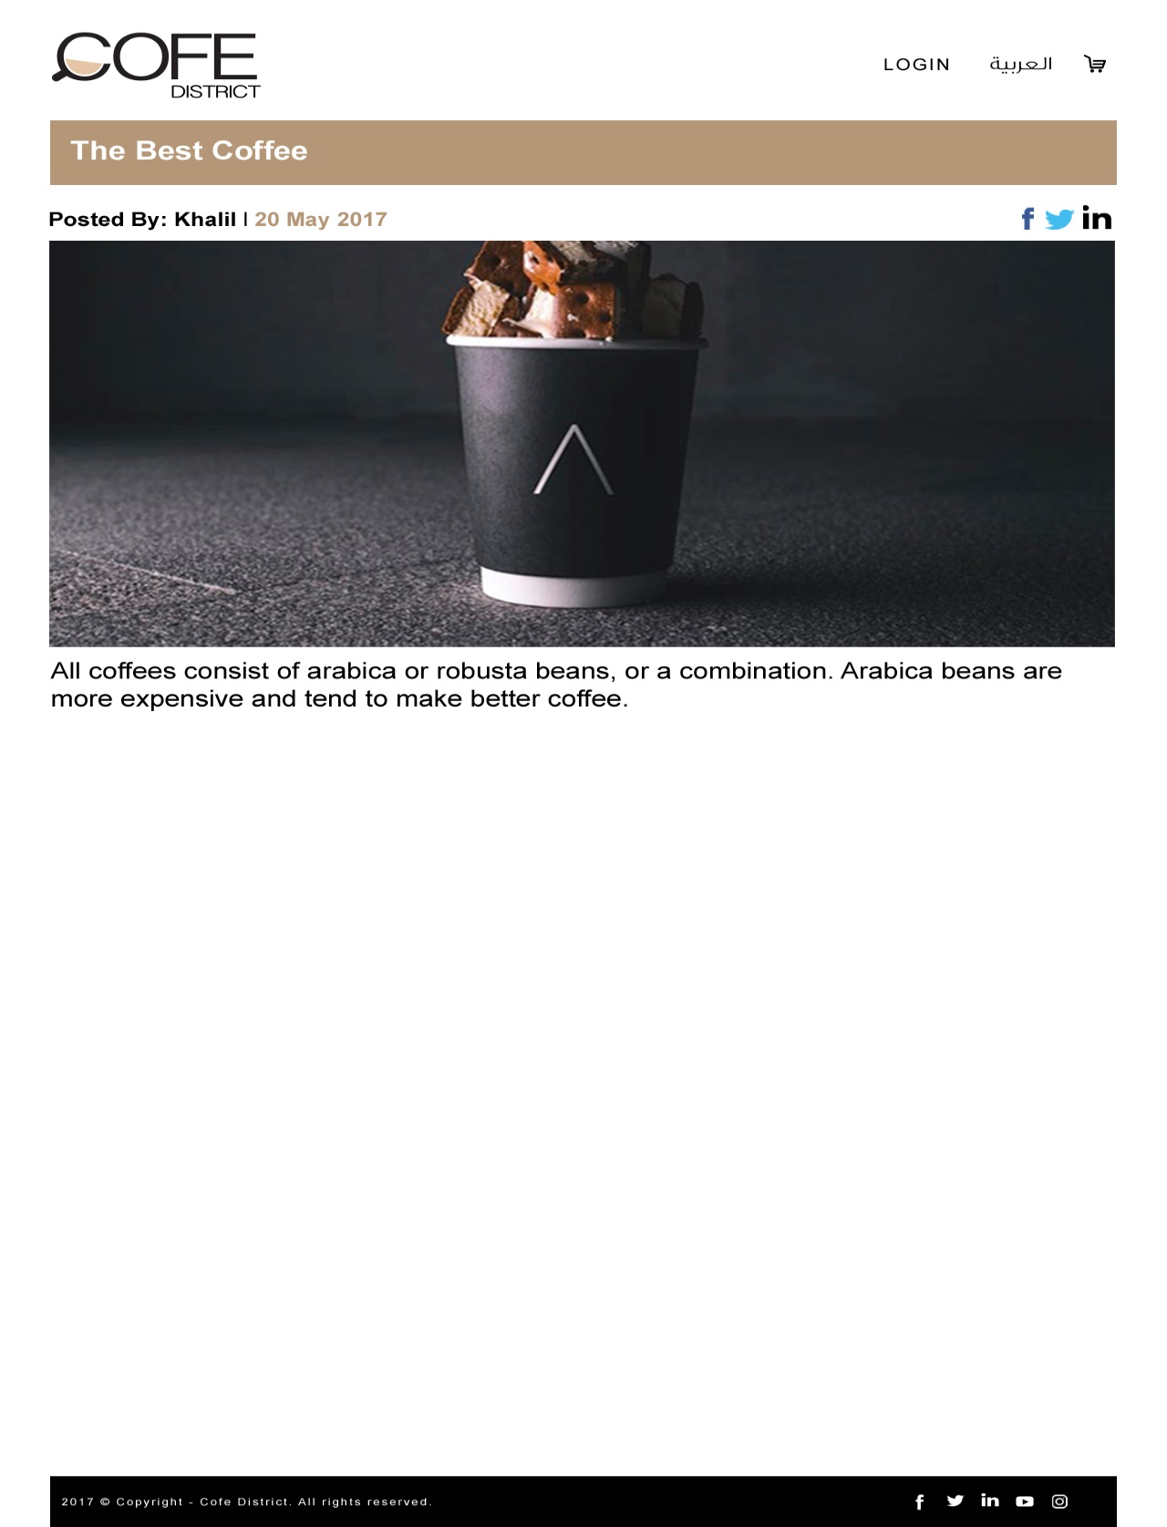

* Gift Cards

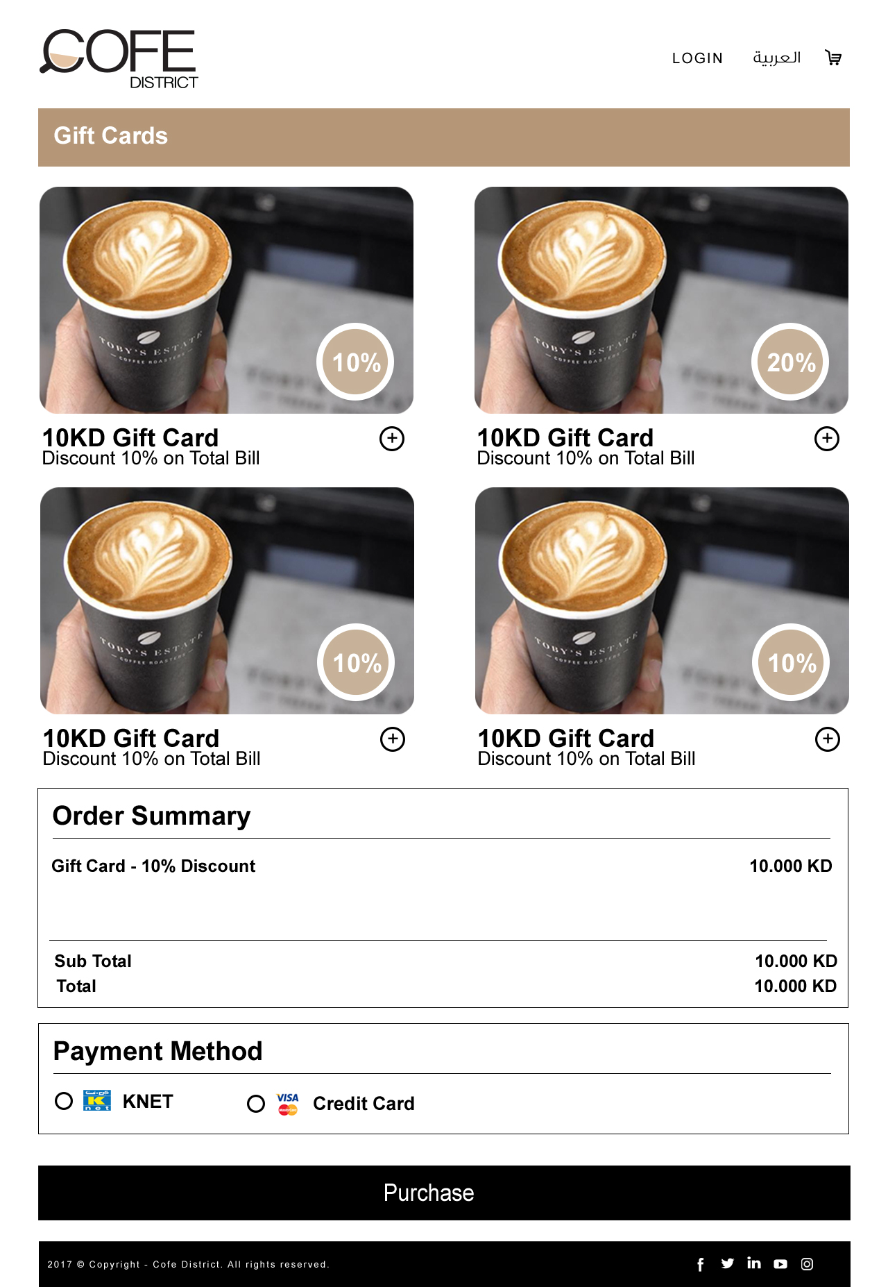

* Offers

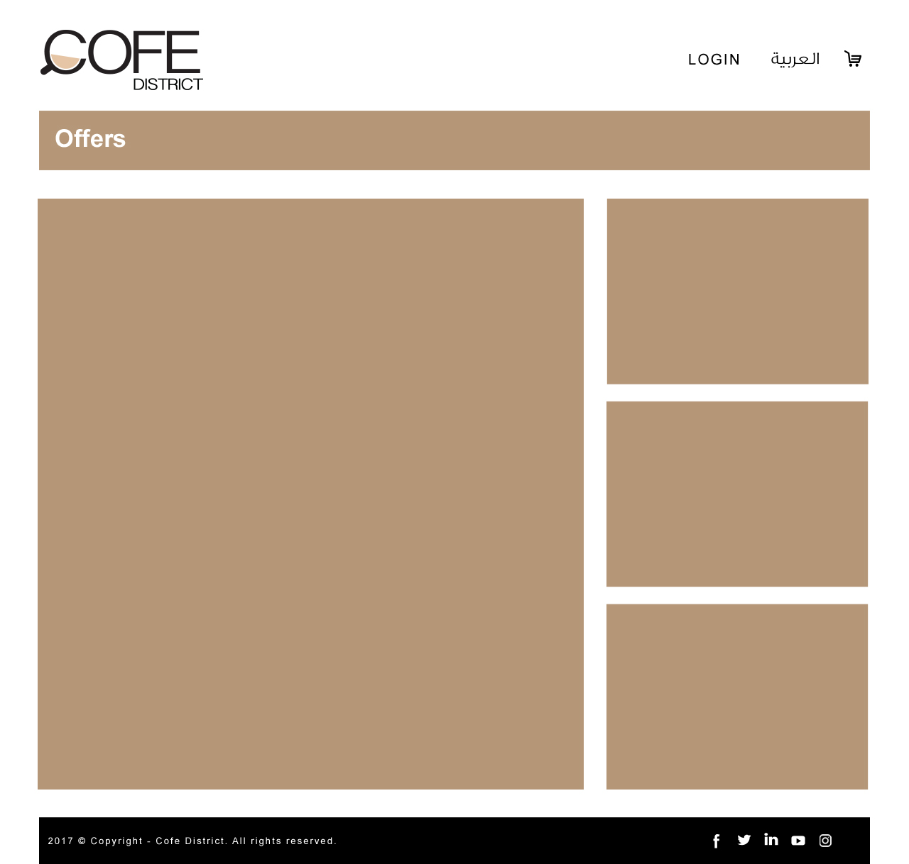

* Catering

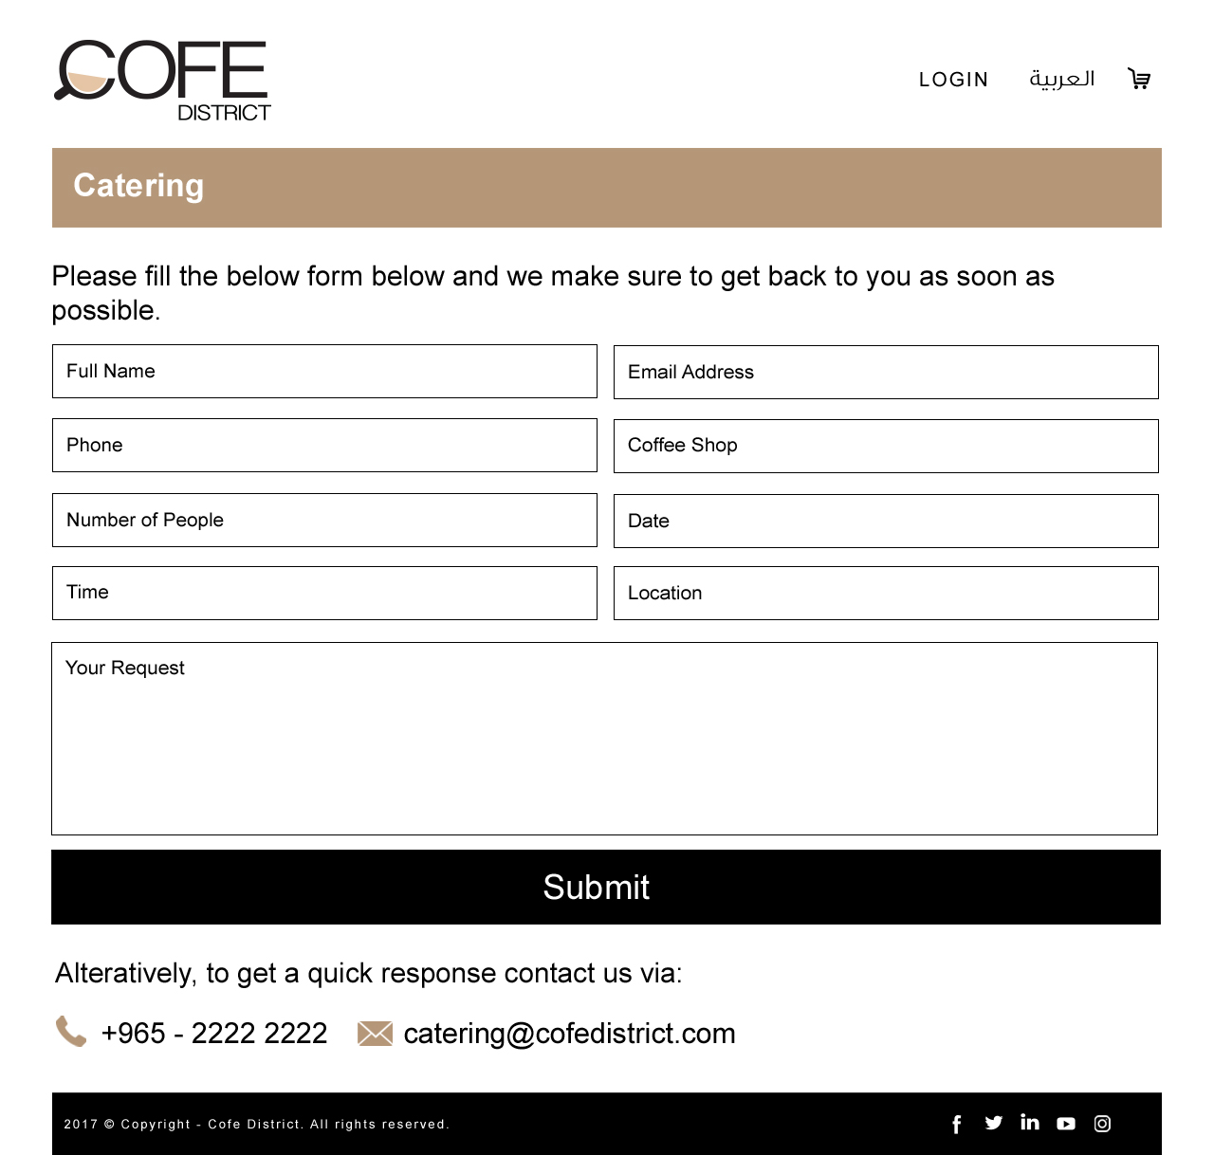

* Checkout

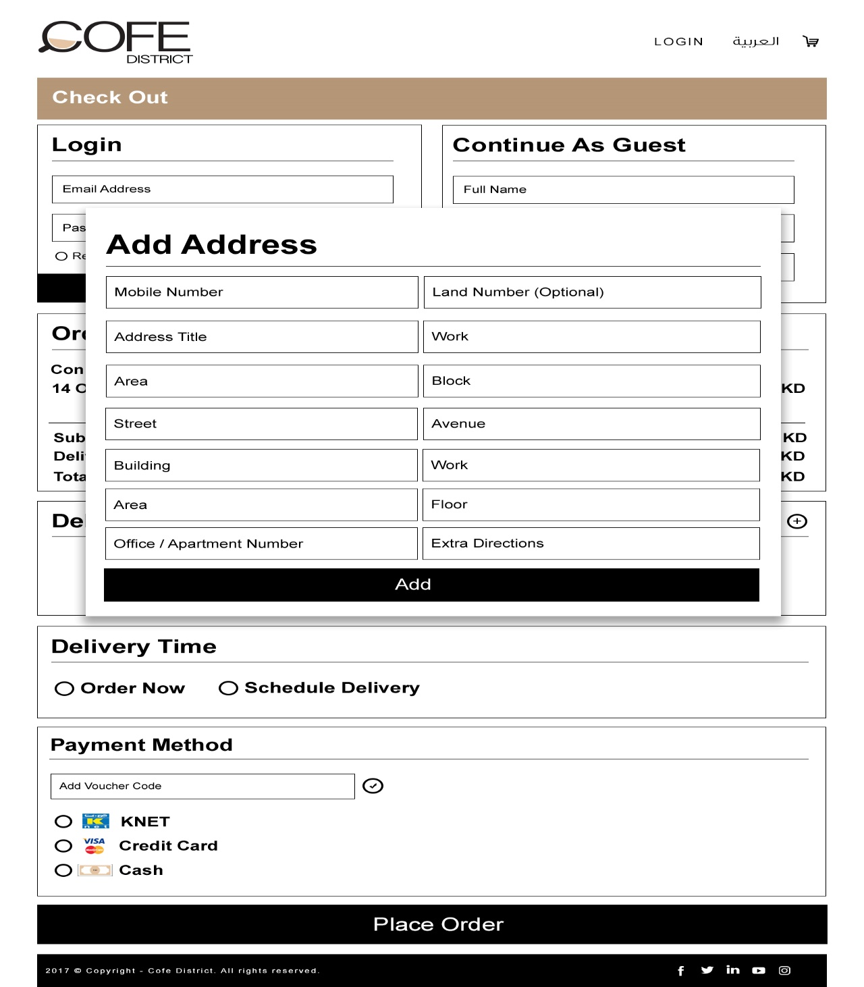

* New Coffee Shop

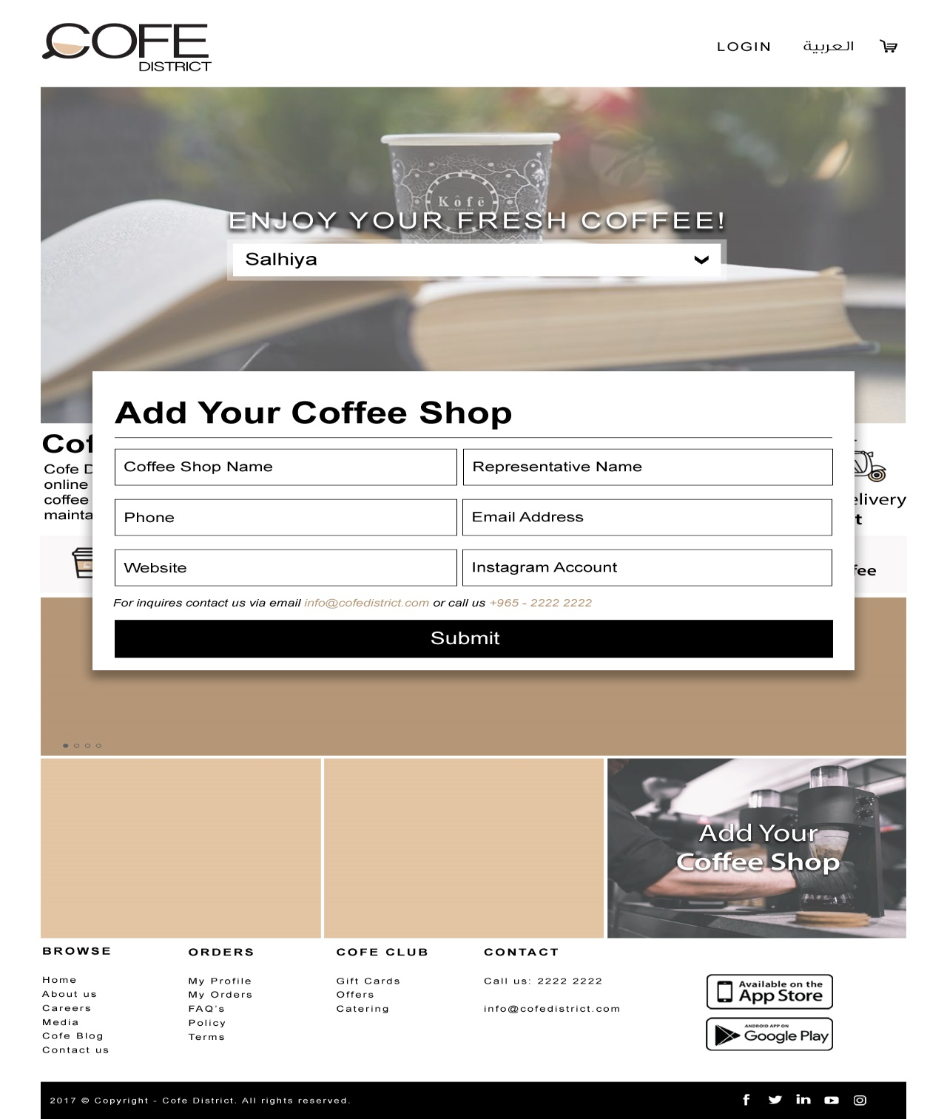

* Privacy - خصوصية الموقع
  + Company privacy خصوصيات الموقع - // text only, page will be static page(edit by administrator),

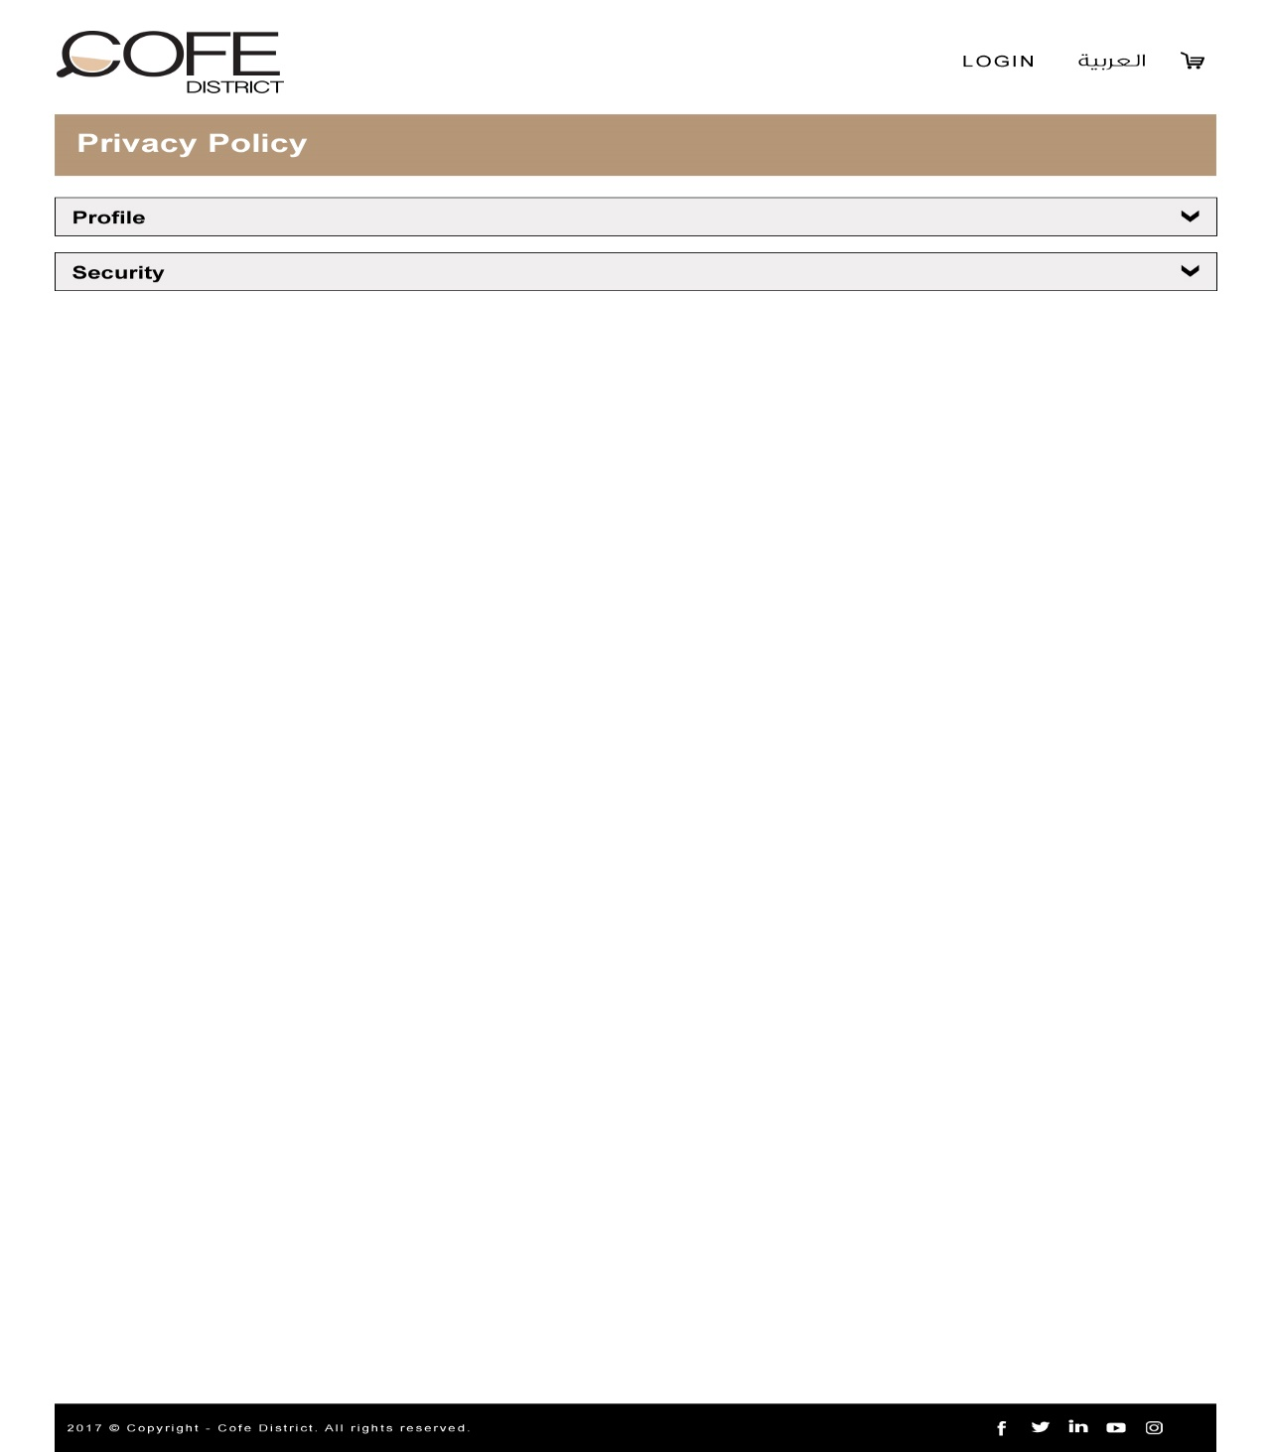

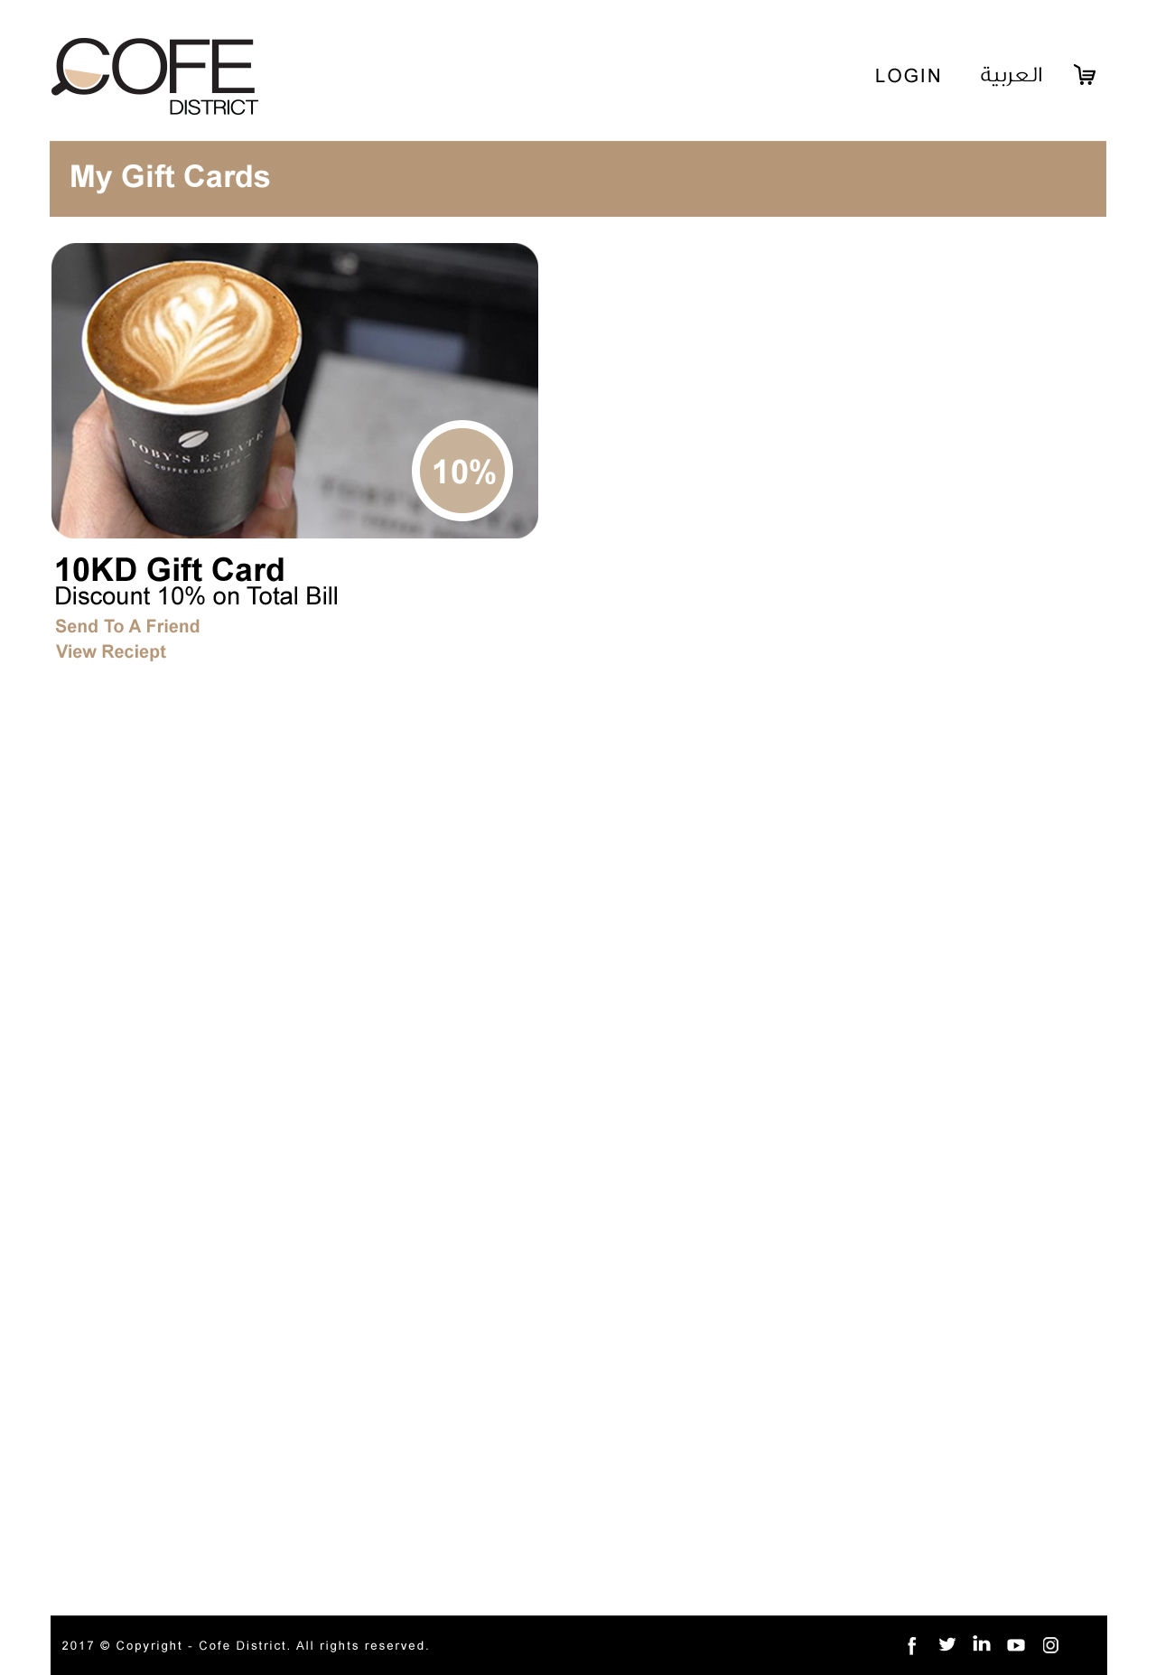

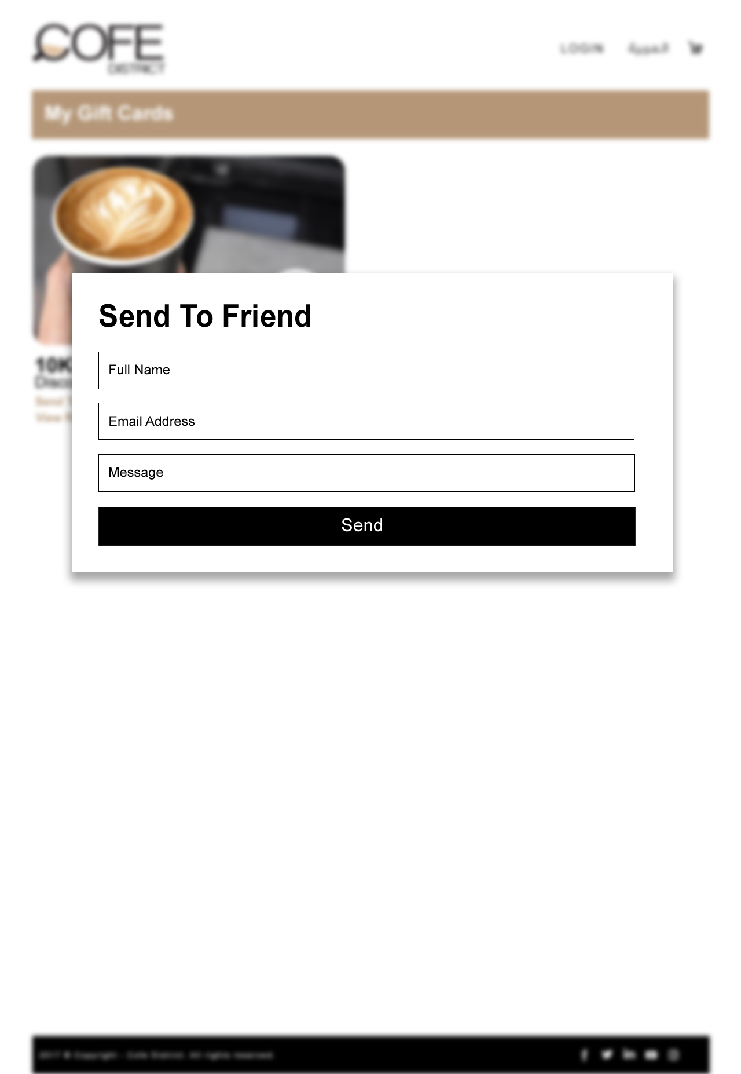

* Terms - الشروط والأحكام
  + Company terms and conditions as text only, page will be static page(edit by administrator),

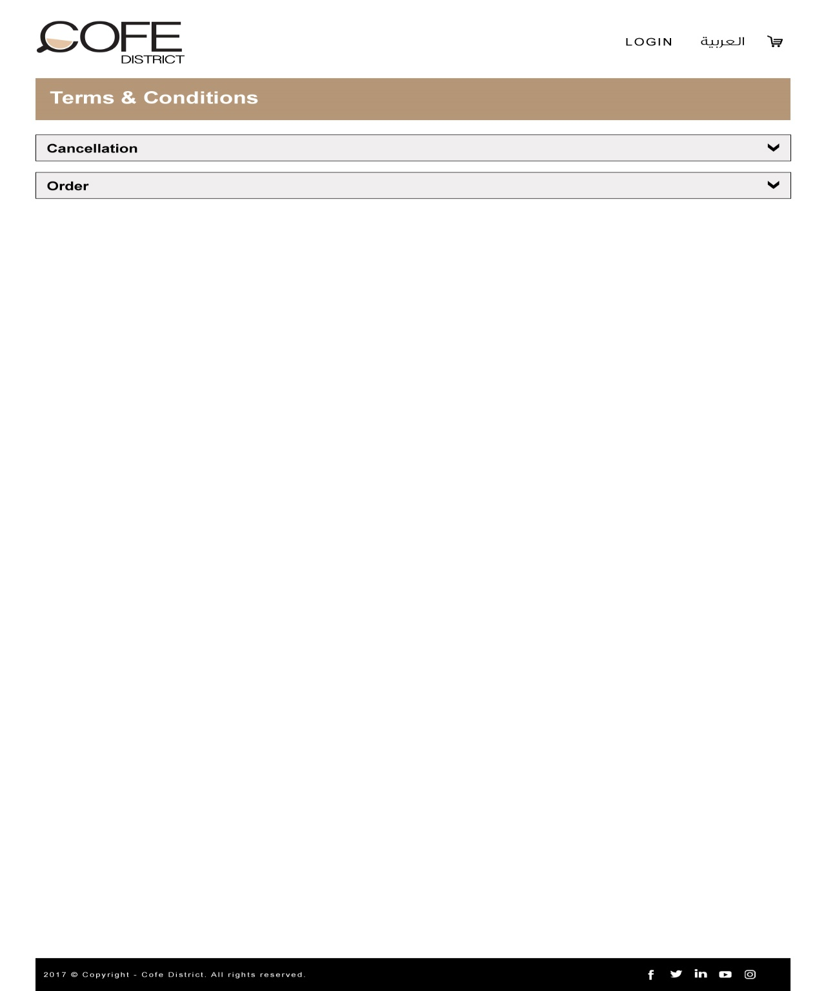

* Feedback - شاركنا رأيك
  + User will be able to send his feedback on site (design, order process, usability) and write his comments then press submit button to send direct to **administrator Email**
* (Frequently Asked Questions (FAQ) الأسئلة المتكررة –
  + to be static Page (edit by administrator), it contains questions & answers

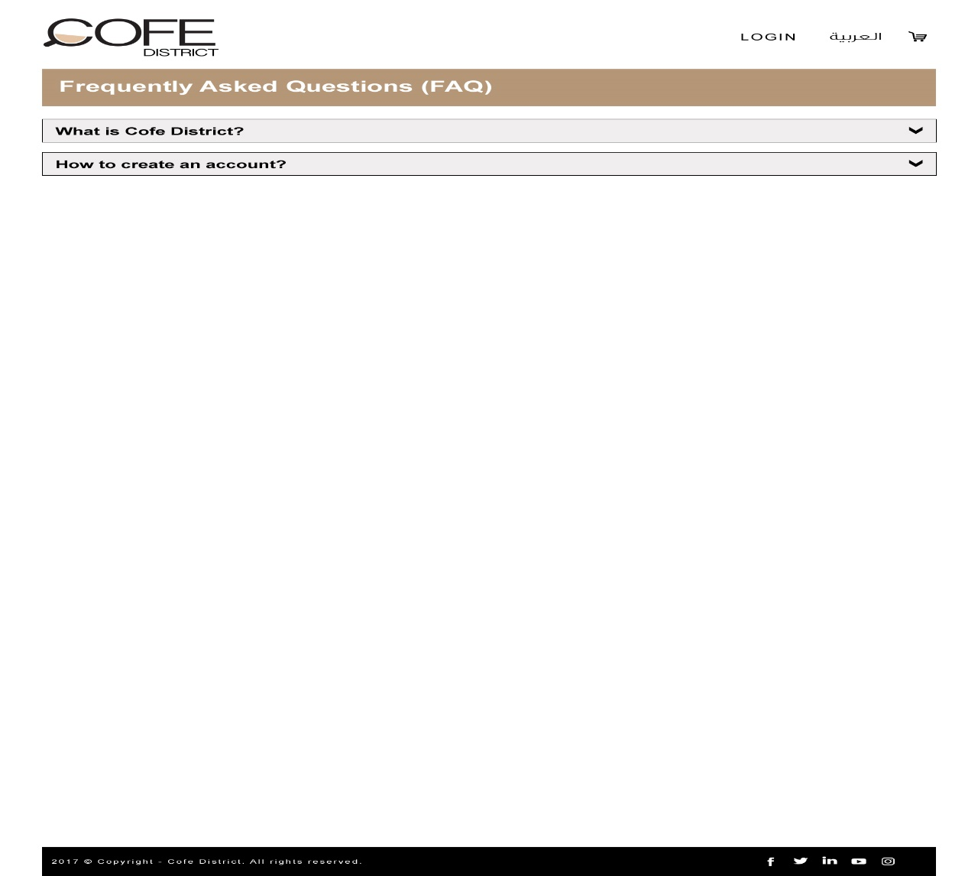

* Contact Us اتصل بنا –
  + user will be able to fill-up his information in the fields such as : (Name, Phone Number, comments)
  + then press submit button to send direct to **administrator Email**

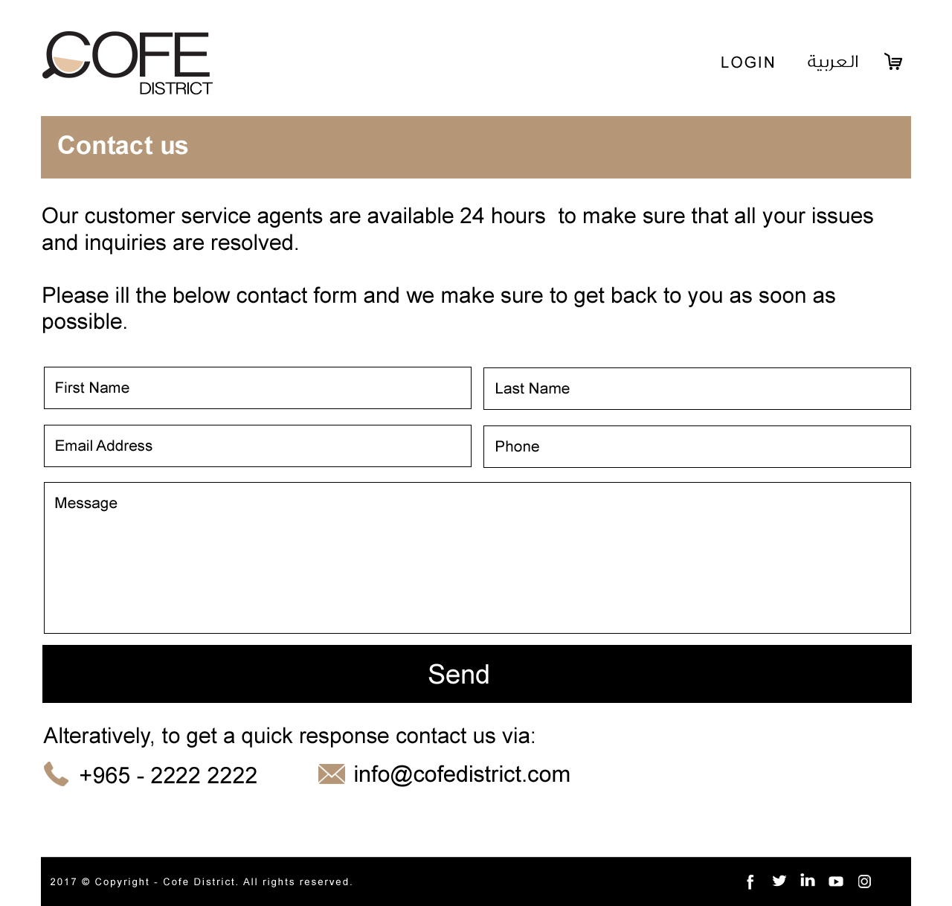

* Privacy Policy سياسة الخصوصية -
  + It will be static page ( edit by administrator) - contain text only
* Site Map خريطة الموقع –
  + It will be static page contains all links of site
* Social Media Link

// sharing page in Facebook, twitter, Instagram, etc…

* My Profile

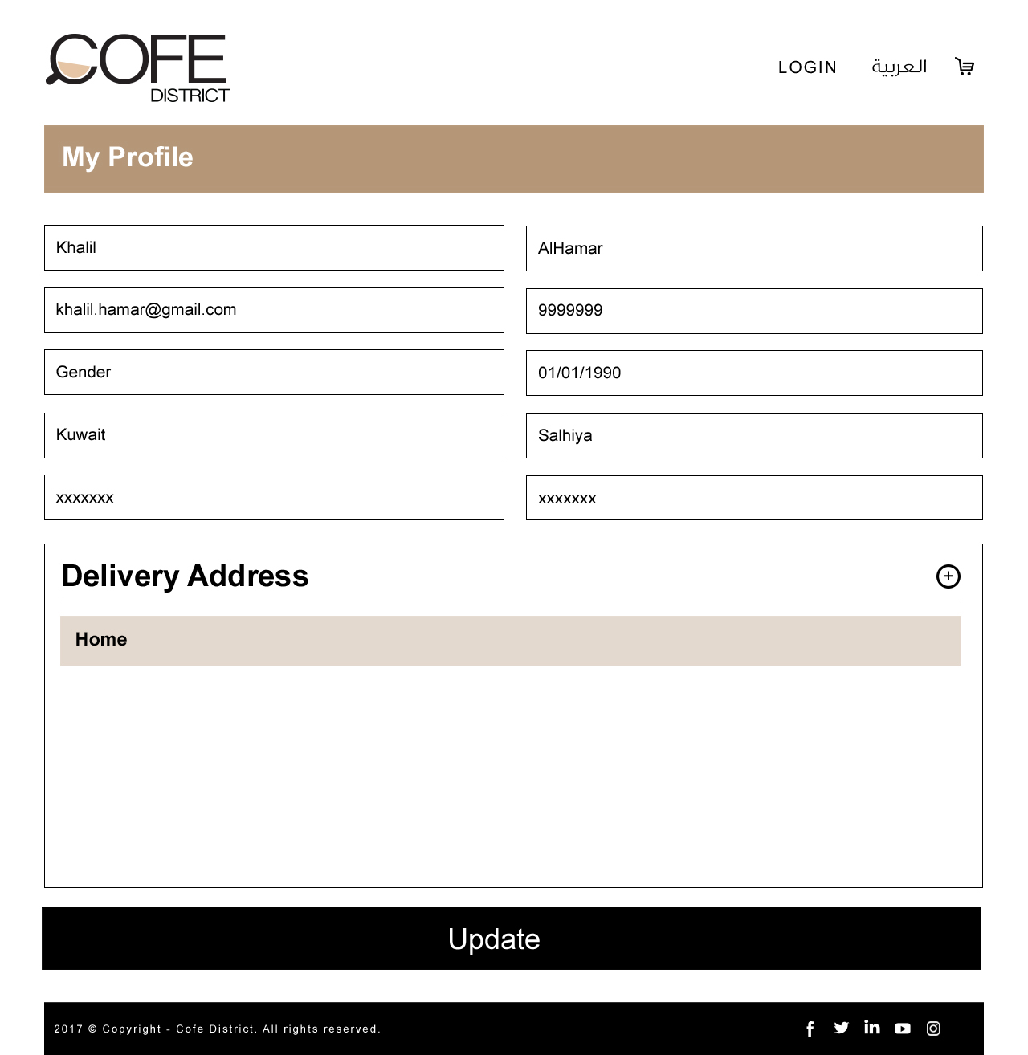

1. **Home Page**

Home page will be the landing page for the Deera Coffee website. By default the landing page will be in English version. Following are the components in the home page

1. Welcome Pop up/Advertisement Pop up //Once closed enter the website
2. Header
   1. Logo
   2. Login //Pop up

2.2.1 Signup Page //Forgot password, Remember me

* 1. My Account
     1. My Orders
     2. My Profile
     3. Saved Addresses
     4. Logout
  2. Arabic/English
  3. My Cart

1. Banner Section
   1. Search by Location
      1. Search Page with Search by location and Coffee Shop and List of All Coffee Shops //The top icon will reflect the selected location
      2. Menu page with Categories, General Information, ratings & Products //If the Shop is closed, user will not be able to order now but can schedule.
      3. Product Description page //Size is required.
      4. My Cart Page //Delivery Fees can be changed from CMS
      5. Checkout Page // Login/Register, Order Summary, Delivery Address, time & Payment Gateway – Order now or Schedule(per day or range) pop up
2. About us
   1. About us info
   2. Delivery<30 mins
   3. No minimum orders
   4. Fixed Delivery Cost
3. Order flow steps
4. Advertisement Banners (1 Main and 3 Sub)
   1. Main Banner – Slideshow
   2. 2 Sub ads
   3. Add your Coffee shop form pop up
5. Footer
   1. Browse
      1. Home
      2. About us //Content, Video & Images
      3. Careers
      4. Media
      5. Cofe Blog //Search Bar with Blogger or date, with Become Blogger option(Pop up form) and list of Blogs.
         1. Cofe Blog article with Image //Share on social media
      6. Contact us
   2. Orders
      1. My Profile
      2. My Orders //Receipt will be printed by the Coffee Shop & Users will have it
         1. Current Orders
         2. Completed Orders //Users can reorder
      3. Order Summary //Track Order
      4. FAQs //Questions & Answers
      5. Privacy Policy
         1. Profiles
         2. Security
      6. Terms & Conditions
         1. Order Cancellations
         2. Licenses
   3. Cofe Club
      1. My Gift cards //List of Gift cards with Order summary & Payment gateway
         1. Gift Cards // Gift card with Send to friend form pop up & View Receipt
      2. Offers // Linked to the Coffee Shop Offers tab
      3. Catering //Form which will ask for Customer details, saved in cms
   4. Contact // Phone and Email
   5. Download Android & IOS icons
   6. Copyright info
   7. Social Media icons
      1. Facebook
      2. Twitter
      3. Linkedin
      4. Youtube
      5. Instagram

Home Banner

The banner images for the home page will be displayed here. The banners will be displayed in slider, and the slider will be auto sliding.

All banner images can be managed from the admin panel. Add, Edit and Delete of banners can be done from the admin panel by the Deera Coffee admin.

Following details of each banner can be managed from the admin panel

* + - * Banner Image
      * Display Order

The Deera Coffee admin can have additional option to disable/enable any banner image from the admin panel.

**Current Location:**

The website will be integrated with a current location option by getting the IP address.

Users can select the locations by selecting the current location (IP address) or select the locations from a list.

The current location option will be exists in home or other pages.

Users can provide the location by selecting it from a list or use a current location option, users have an ability to change the location that he/she selected.

Order Your coffee

This will allows the user to search for Coffee Shops that are based on location. For searching the Coffee Shops, the user have to select the following details

* + - * Area - List of locations added from the admin panel

There will be “Find Coffee Shop” link to search for the Coffee Shops with the selected area. If any of them (Area) are not selected, then the system will show message to the user to select the specific values. The search will be only performed after user selects the area.

After user click “Find Coffee Shop” with all the required values in Area, the page will be redirected to Coffee Shop listing page. The Coffee Shops list will be filtered based on the selected area.

There will be dropdown selection for Area to allow the user to change and find the Coffee Shops of different areas.

The “Search Coffee Shops” text box with search button allows the user to search for any specific Coffee Shops with the search keyword. For searching any Coffee Shop, user must enter any text in the text box. If the user search for Coffee Shops without entering the keyword, a popup message will display to the user that he needs to enter any search keyword.

Current Orders

Current orders section displays the latest orders for different Coffee Shops. This section will be displayed as a slider, so that the latest orders will be displayed randomly in a specific time interval.

This section will display latest 50 orders with respect to the date and time. The following details will be displayed in the slider

* + - * Thumbnail of the ordered item
      * Ordered item name
      * Order To : (Order delivery location)
      * From : (Order placed location), Date of order (DD MMM)

There will be “Find Coffee Shop” link to search for the Coffee Shops with the selected area and cuisine.

About Deera Coffee

A brief summary about Deera Coffee will be displayed here. This content can be edited from the admin panel by the Deera Coffee admin. This section includes the below

* + - * Title
      * Summary
      * Read more link

The read more link allows the user to navigate to the “About us” page of the Deera Coffee website and this page will have the full details about the Deera Coffee.

Browse by Coffee Shops

This section allows the user to search for foods in any specific Coffee Shops. There will be a dropdown list of Coffee Shops that allows the user to search for the food items in any specific Coffee Shop. Following are the options in the dropdown list

* + - * Select Any
      * Coffee Shop names list
        + Coffee Shop 1
        + Coffee Shop 2
        + Coffee Shop 3
      * All

“Select Any” will be the default selection in the dropdown list, and any changes in the default selection by the user will provide him the search result based on the selected value.

If the user selects any Coffee Shop’s name from the list, user will be redirected to the specific Coffee Shop’s details page.

If the user selects “All”, then the user will be redirected to the listing page of the Coffee Shops.

Browse by Area

This section allows the user to search for Coffee Shops in any specific area/location. There will be a dropdown list of areas that allows the user to search for the Coffee Shops in any specific area. Following are the options in the dropdown list

* + - * Select Any
      * Area names list
        + Area 1
        + Area 2
        + Area 3
      * All

“Select Any” will be the default selection in the dropdown list, and any changes in the default selection by the user will provide him the search result based on the selected value.

If the user selects any area’s name from the list, user will be redirected to the Coffee Shops listing page. The Coffee Shop list in the page will be filtered based on the selected area, and so that the Coffee Shops that are in the specific location will be only displayed in the page.

If the user selects “All”, then the user will be redirected to the listing page of the Coffee Shops and the Coffee Shop list will be for all the areas.

1. **All Coffee Shops**

This page will have the list of active Coffee Shops that are added by the Deera Coffee admin from the admin panel. There will be only one banner image for the page, and it will be static and so the Deera Coffee admin cannot change this section.

The page name of the “All Coffee Shops” page will be displayed with a thumbnail image. This also static and so the Deera Coffee admin cannot change this section.

This page also have the “Search Coffee Shop” section to allow the users to search for Coffee Shops with any search keyword. For searching any Coffee Shop, user must enter any text in the text box. If the user search for Coffee Shops without entering the keyword, a popup message will display to the user that he needs to enter any search keyword.

If the user search for any Coffee Shop, the Coffee Shop list will be updated with the search result. If there is no Coffee Shops that are matching with the keyword that the user entered, then the Coffee Shop listing section will display “No Coffee Shops found”.

The list of Coffee Shops will be ordered randomly on each page refresh. The list will have the following details for each Coffee Shop

* + - * Thumbnail Image
      * Coffee Shop Name
      * Rating (Total 5 Stars)

*Rating*: - Rating of each Coffee Shop will be displayed in the list using stars. There will be 5 stars and this will be filled with respect to the rating of the specific Coffee Shop. Registered users can give ratings for all Coffee Shops after logged in to the system. Guest users don’t have permission to give ratings for Coffee Shops, for that he/she needs to register in the system. For giving rating, the registered user needs to click on the rating of any Coffee Shop and this will show a popup with the following details

Coffee Shop Thumbnail

Coffee Shop Name

Rating of the Coffee Shop in number

Blank stars (Maximum 5), for selecting the rating of the Coffee Shop

Submit button

Clicking on each Coffee Shop details will redirect the user to the specific Coffee Shop’s details page.

Number of Coffee Shops listed will appear near to the “Coffee Shop” text

Coffee Shop Details Page

In the details page of the Coffee Shop, the user have to select the area of the Coffee Shop. The areas in which the selected Coffee Shop is available will be listed in the dropdown list.

First, the user have to select any particular area from the list and this will show the below details of the specific Coffee Shop in the selected area

* + - * Status (Open/Closed)
      * Minimum Amount (In KD)
      * Working Hours (From HH:MM AM/PM to HH:MM AM/PM)
      * Delivery Time
      * Delivery Charges (In KD)
      * Payment Methods available for the Coffee Shop
      * Rating
      * Show Menu – Link to Menu detail page

User can view the menu of the specific Coffee Shop in the selected area only if the status is “Open”.

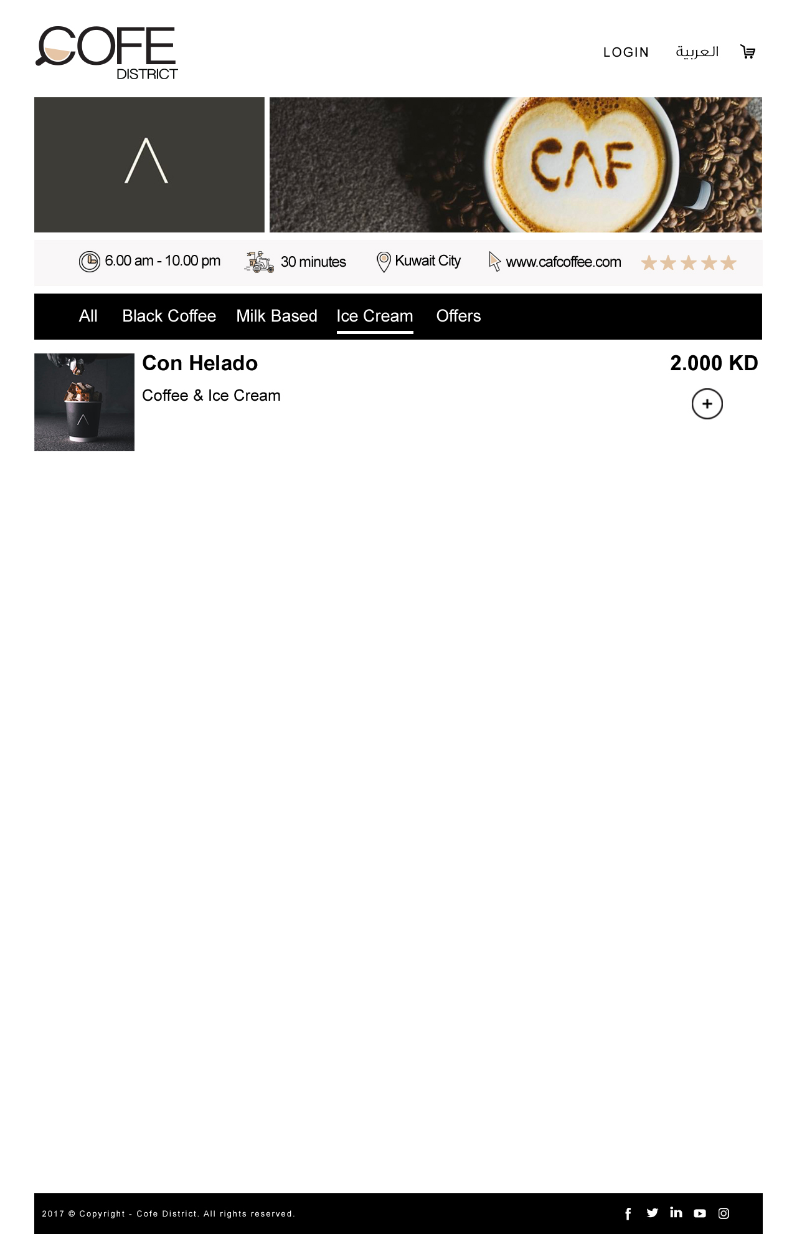

*Rating*: - As explained above.

The menu listing page of the Coffee Shop have the following details

* + - * Banner Image (Only one banner and it is static)
      * Coffee Shop Thumbnail
      * Coffee Shop Name
      * Menu Name 1
        + Food item 1

Thumbnail Image

Food name

Rating

Price (In KD)

Quantity

Order Button

* + - * + Food item 2

Thumbnail Image

Food name

Rating

Price (In KD)

Quantity

Order Button

* + - * Menu Name 2
        + Food item 3

Thumbnail Image

Food name

Rating

Price (In KD)

Quantity

Order Button

* + - * + Food item 4

Thumbnail Image

Food name

Rating

Price (In KD)

Quantity

Order Button

This page will list all the menu items available for the selected Coffee Shop (with respect to the selected area). Each menu items may have multiple food items that are added from the admin panel by the Coffee Shop manager.

*Rating*: - As explained above.

*Quantity*: - Each food item in the menu will have the disable text that showing the quantity of the item. By default it will 1 and there will be option for the user to increase or decrease quantity and then adding to his/her food cart. The minimum quantity will be 1 for all food items.

Guest and registered users can order the food items from the page. There will be “Order Now” button to add the food item to his/her food cart. While ordering each food item, the user’s food cart will be updated and it will be displayed in the food cart.

The Coffee Shop will add all cities and locations in admin panel that can cover, the user can show the list of these cities and locations provided by Coffee Shop admin.

Food Cart

The food cart will be available on side section of the menu listing page after the user order any food items. This will have the summary of food items that are currently added to food cart by the user.

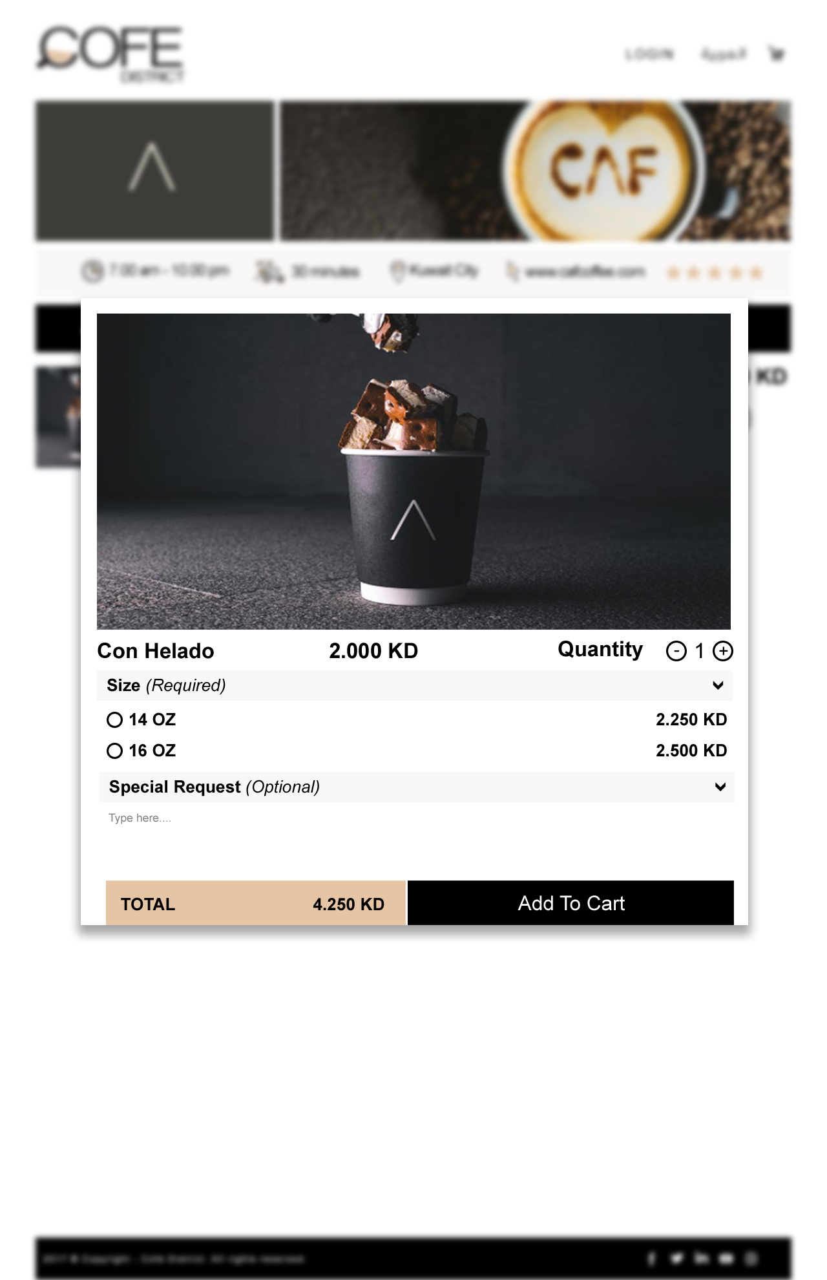

The following will be in the food cart details

* + - * Thumbnail of each item
      * Name of each item
      * Total amount in KD for each item
      * Remove option for each item
      * Grand Total of the food cart
      * Checkout Button

If any of the food items for any particular Coffee Shop is not having the minimum order amount, then the “Checkout” button will not be visible to proceed to checkout.

When the user clicking on the “Checkout”, the system will check whether the user is logged in or not. If the user is already logged in, then the user will be redirected to checkout page.

If the user is not logged in the system, then he will be redirected to a page where he can have the following options

* + - * Login and proceed to checkout
        + Forget Password
      * Create New Account
      * Continue as Guest

*Login and proceed to checkout*: - This allows the user to login to his/her account with the user name and password and then the system will automatically proceed to checkout for completing the order.

*Create New Account*: - This allows the user to create a new account in Deera Coffee website as a customer user role. After creating the account, the system will automatically proceed to checkout page for completing the order. Customer registration details will be explained later.

Continue as Guest: - This allows the user to complete the order without creating any account in the Deera Coffee website. If the user selects this option, the user will be proceeded to checkout page and then he have to fill all the required fields in the delivery location and contact details.

The checkout page will have the following sections

* + - * Delivery Information
      * Order Summary
      * Payment Methods
      * Place Order.

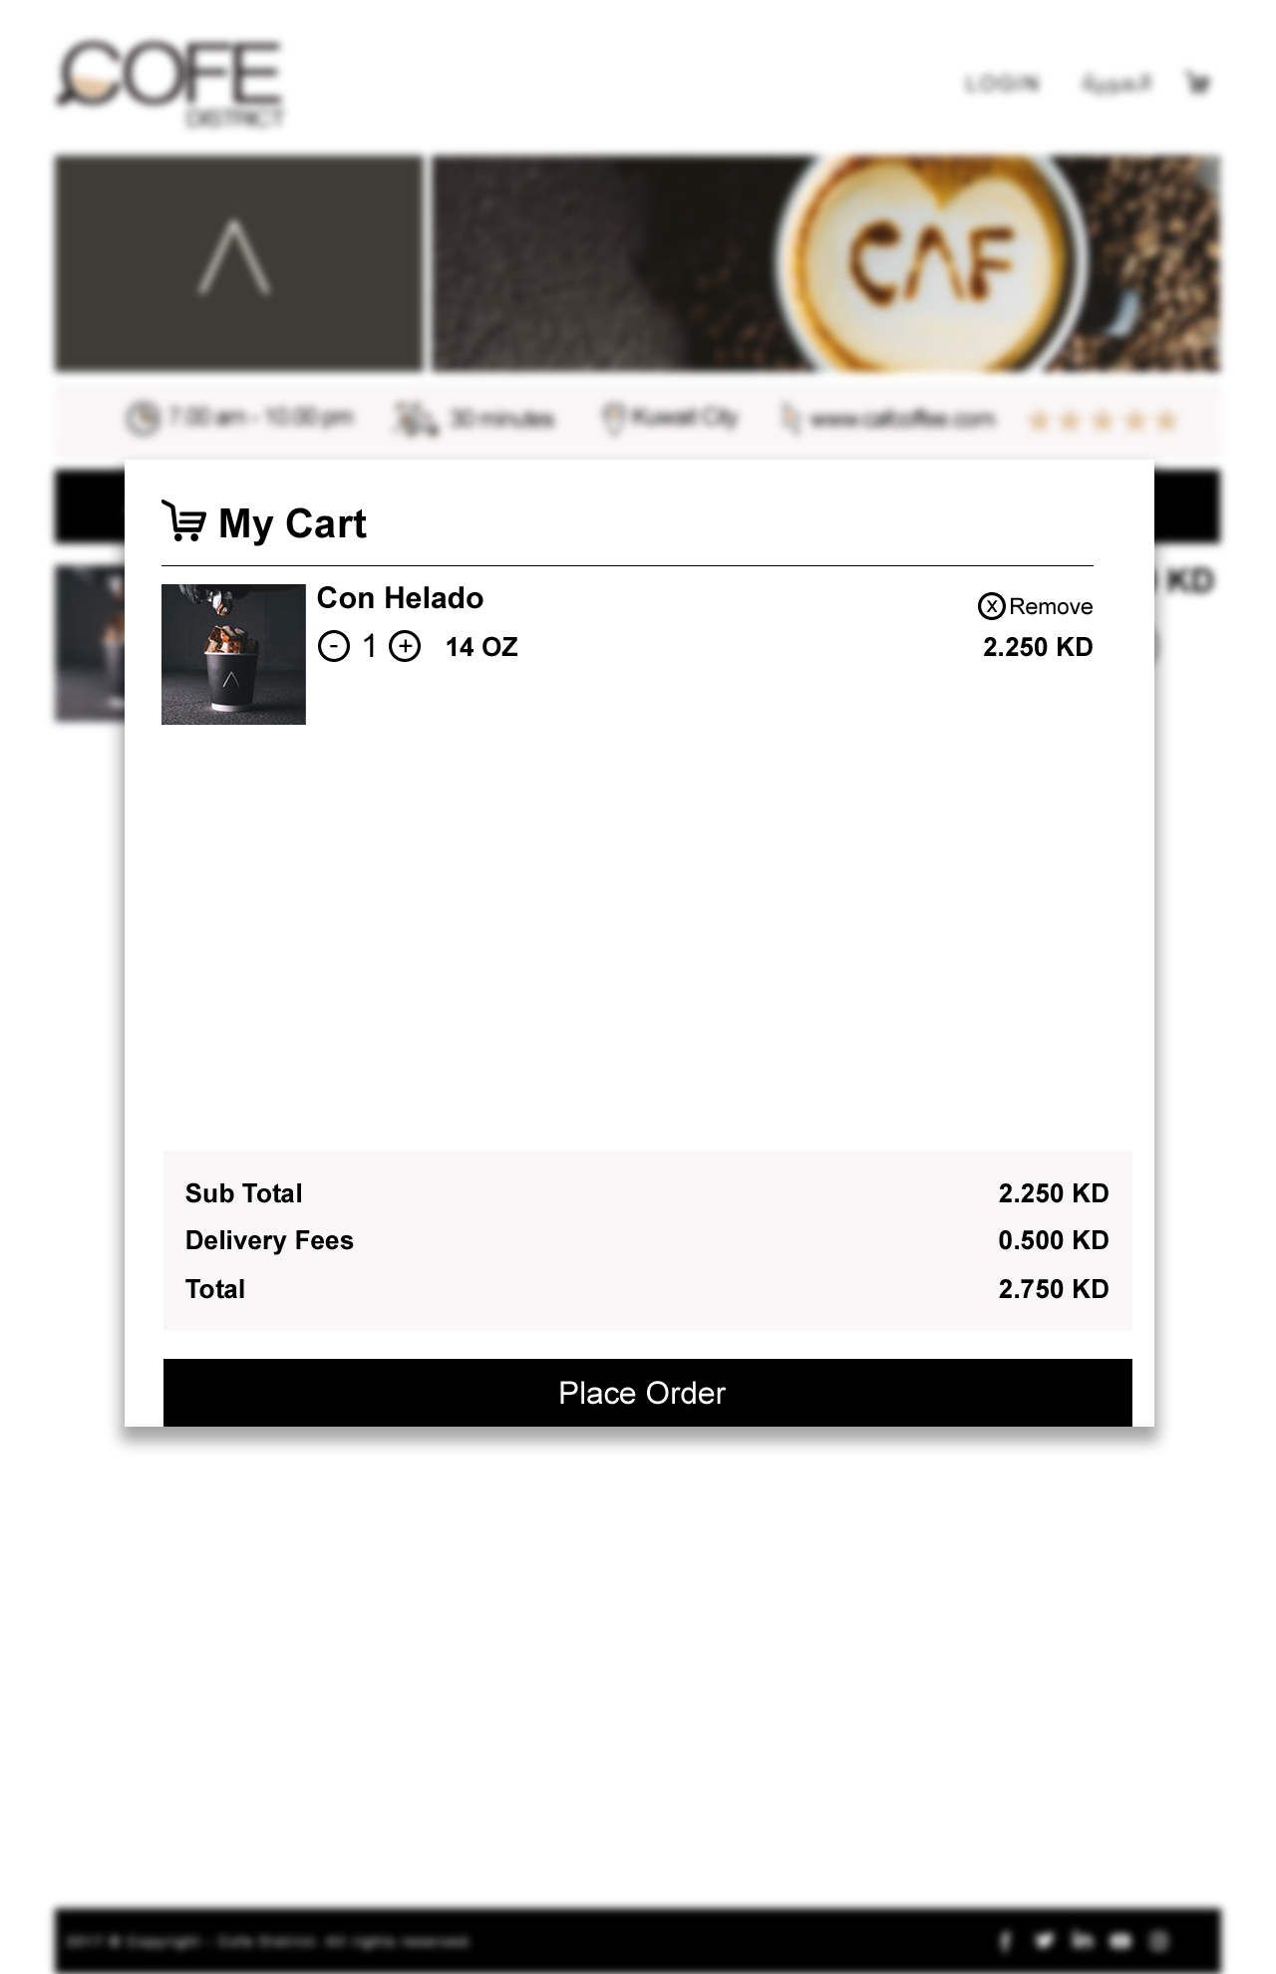

Delivery Information

This allows the logged in users to select the delivery locations that are already added from his profile pages. The delivery locations will be as of 3 types

* + - * Apartment
      * House
      * Office

The logged in users can select any of the above that are already saved from his profile pages and then it will fill the delivery locations based on the area he/she saved. If there are multiple delivery locations based on the areas are saved by the user, then the area dropdown will list the areas that he saved for the delivery locations. From the list, he/she can select any area available and then the delivery location will be filled automatically.

If the user is guest user, then he/she have to enter all the required fields for delivery location and contact details.

There will be option to add new location for the logged in users and enter location for guest users, then a popup will be displayed and then it will load the current location of the user in google map or user can select location manually from google map. After selecting the location, the user needs to proceed to add the address in the popup. Following are fields for the delivery address

* + - * First Name – will be filled automatically for registered users after login
      * Last Name - will be filled automatically for registered users after login
      * Available in Kuwait city only
      * Address Type (Apartment/House/Office)
      * Block (Optional)
      * Street
      * Avenue (Optional)
      * Building
      * Floor
      * Apartment Number
      * Mobile Number
      * Phone Number (Optional)
      * Additional Directions (Optional)
      * Save and Proceed button – To save and proceed to order summary

After clicking the save and proceed, the address information will be saved in the backend with the geo location details from the google map.

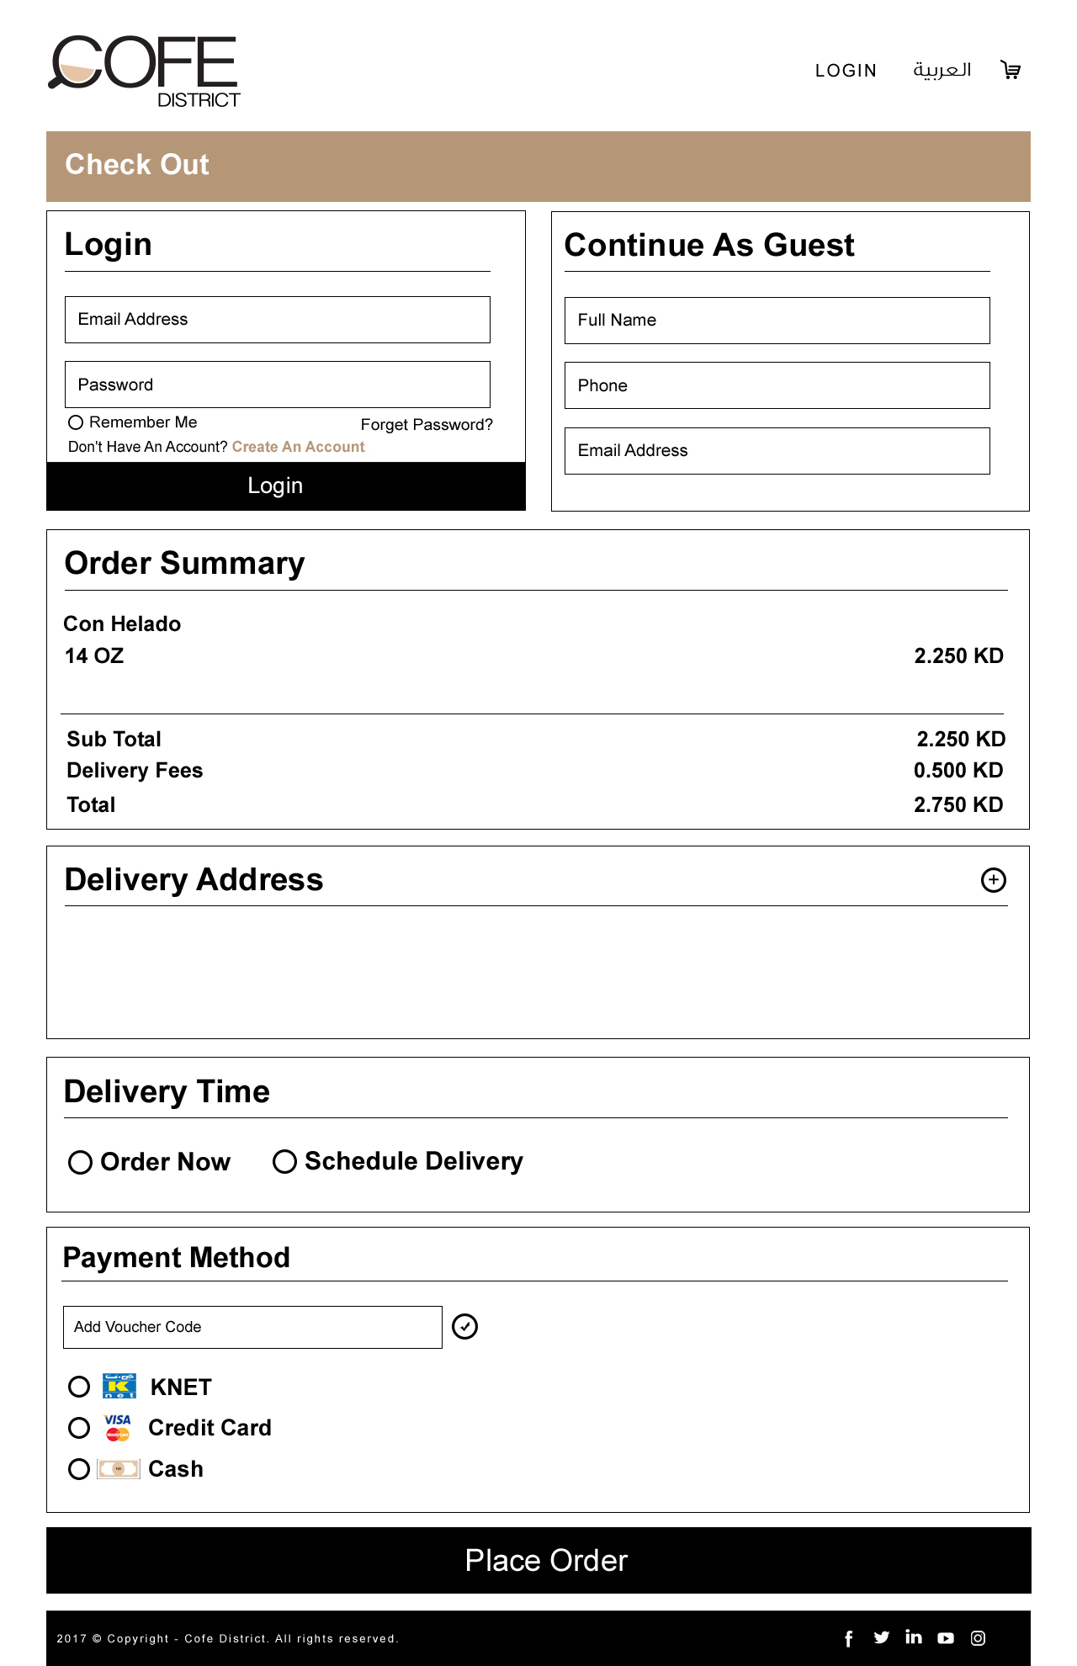

After selecting the delivery location, the user can proceed to order summary section.

Order Summary

This section will have the details of each food items he/she ordered as below

* + - * Payment methods available
      * Menu
        + Item name
        + Quantity
        + Unit Price (In KD)
        + Total Price (In KD)
        + Special request (Text area)
        + Remove button – For removing items from the order

The user can select the delivery time as below

* + - * Now
      * Pre-order for later – User can select date till the post order date that accepts the Coffee Shop
        + If today is Sunday and time is 12:30 PM and Coffee Shop post order date accepts 3 days then the list will have date and time from Sunday 01:45 PM to Tuesday 12:30 PM
        + List of date time will be for each 15 min time interval (Sunday 12:30, Sunday 12:45, Sunday 01:00 etc.).

Now: - This allows the user to place order for now.

Pre-order for later: - This allows the user to place the order for a selected date time. This will depends upon the post order days of Coffee Shops. If the Coffee Shop accepts 3 days as post order days, then the user can select a “pre-order for later” date to 3 days from current date time.

If food items from multiple Coffee Shops are selected then the shortest of the post order day Coffee Shops will be taken for the pre-order for later.

Payment Methods

The user can select the type of payment from this section. There will be the following payment methods available for Deera Coffee

* + - * Cash On Delivery
      * KNET
      * VISA/MasterCard

Guest and Registered users can use all the above payment methods for completing the order in Deera Coffee.

If any of the Coffee Shop that the user have ordered food items, that don’t have one of the payment methods above, then the specific payment method will not be available for the order.

After selecting any of the payment methods from the page, user can complete the order by clicking on the “Place order” button.

If the payment method is “Cash on Delivery”, then the order will be successfully completed at the same time and the user will be redirected to thank you page with all the details about the order. There will be print option for the user to print the details. The same details will be send to the users email.

If the payment method is “KNET” or “VISA/MasterCard”, then the user will be redirected to the payment gateway page with secure connection (SSL). After completing successful payment, the order will be placed and the user will be redirected to the thank you page with all the details (order and transaction) about the order. If the payment is not successful or cancelled, the order will not be placed and the user will be redirected to the “payment not complete” page with the transaction details. There will be print option for the user to print the details. The same details will be send to the users email.

All of the transaction details will be saved to the backend for keeping track of the transactions.

After a payment proceed is succeed, the user can track the order from two options:

“Track my order” this option for the logged in users , if a user clicked on this note will be redirected to the “Track My Order ” .

1. New Coffee Shops

This page will show the list of Coffee Shops that are added recently from the admin panel by the Deera Coffee admin. This page will have the same look and functionality of the “All Coffee Shops” page but only difference is that this page will list only the new Coffee Shops of Deera Coffee website.

Whenever super admin creates a Coffee Shop in Deera Coffee website, the “New Coffee Shops” page will show the specific Coffee Shop for 1 month.

While searching for the Coffee Shops using “Search Coffee Shop” section, the system will search and list the Coffee Shops which recently added and that are matching with the search keyword.

Each Coffee Shop in the list will be linked with the details page of the specific Coffee Shop.

1. Most Selling coffee

This page is used to list out the most selling coffee of the Deera Coffee website. This includes food items from all the Coffee Shops. This page have the following filters as below

* + - * Best Sellers
      * By Coffee Shop

The food items which are set as best seller from the admin panel will be displayed as best seller item for the Coffee Shops. Multiple food items can be set as best seller for each Coffee Shop.

By default “Best sellers” will be selected and the list of best seller items will displayed in the page. The list will be ordered randomly on each page refresh.

Best Sellers

This will show the list of best-selling food items of all Coffee Shops. Following are the details available in the best sellers list

* + - * Thumbnail image of the food item
      * Dish name
      * Coffee Shop name

Each item will be linked with the specific Coffee Shop details page. In the details page, the best-selling coffee will be displayed on the top of the page with a separate heading “Best Selling”.

All the other functionalities are same as the Coffee Shop menu details page from “All Coffee Shops”.

By Coffee Shop

This will show the list of Coffee Shops that are not disabled from the admin panel. The Coffee Shop which don’t have any best-selling product will not displayed in the Coffee Shops list.

Each Coffee Shop in the list will have the following details

* + - * Thumbnail Image
      * Coffee Shop Name

Clicking on any Coffee Shop details will display the best-selling coffee list for the specific Coffee Shop.

This will have the following details

* + - * Thumbnail Image
      * Dish Name

These above details will be linked with the specific Coffee Shop details page. In the details page, the best-selling coffee will be displayed on the top of the page with a separate heading “Best Selling”.

All the other functionalities are same as the Coffee Shop menu details page from “All Coffee Shops”.

1. **Login**

The login link in the website header allows the customers to login to the website as registered user and can manage his/her account from the profile pages.

When the user clicks on the login button, the user will be redirected to the login page in the website. The login page will have the following details

* + - * Login section
        + Email
        + Password
        + Login
      * Forgot Password?
      * Create New Account

These are the options available in the login page of the website. The login section allows the user to login to the website using his/her registered email id and password. The user have to enter the valid and existing email and password to login to the website, otherwise the system will show the error message and will not allow the user to login.

There will be required field and regular expression validations for entered email and passwords.

After user enter valid account credentials and clicking “Login” button, the system will redirect the user to his/her profile pages. The profile pages will have the following sections

* + - * Account Dashboard
      * Address Management
      * My Orders
      * Change Password

A customer can login by using one of the following:

* Social media accounts
* Gmail plus

A customer can login with username or email Id

Account Dashboard

By default the profile page will display the account dashboard and will have his personal information as below

* + - * First Name
      * Last Name
      * Mobile Number
      * Phone Number
      * Gender (Male/Female)
      * Occupation
        + Professional Services
        + Self Employed/Owner
        + Other

Text box for Other occupation details

* + - * Edit/Save

From the account dashboard, the user can view all the personal information of his account.

There will be “Edit” button to edit the information and can update the information by clicking on “Save” button. By default there will be edit button, clicking on edit button will show save button and then it will hide the edit button. When the user clicks on save button, the information will be updated in the database and then the edit button will be displayed instead of save button.

Address Management

This will have the list of delivery addresses that he/she have added. From the list user can select any of the delivery address as primary/default address. This primary address will be the default selection in the delivery address of checkout page.

The list will be in accordion style so that only delivery address name will be listed in the list, and clicking on each address name will expand and will show the specific delivery address details. The details will be as below

* + - * Address Name
      * Address Type (Apartment/House/Office)
      * Block (Optional)
      * Street
      * Avenue (Optional)
      * Building
      * Floor
      * Apartment Number
      * Mobile Number
      * Phone Number (Optional)
      * Additional Directions (Optional)

There will be edit button on each delivery address and clicking on the edit button will allow the user to edit and update the existing delivery details.

While editing the information, there will be option to select the current location of the user in google map or user can select location manually from google map. This will fill the delivery area and then user can enter the other details.

After editing the information, the user can save the delivery address information by using “Save” button.

*Delete*: - In delivery address list, there will be “delete” button for each delivery address in the list. This allow the user to delete the existing delivery addresses. If there is only one delivery address, then the user can’t delete the delivery address.

*Add New*: - This button in the delivery address section allows the user to create new delivery addresses for his/her account. He/she can add multiple delivery address for the below categories

* + - * Apartment
      * House
      * Office

My Orders

This section will display the order history of the specific user. The order will be listed in accordion style and there will be option for the user to select the page size to view the list. The page size will be 10, 50, 100, 200 and the list will be with pagination.

The list will show the following details by default

* + - * Date
      * Delivery Address Name
      * Total Price in KD

Clicking on each order will show the full details about the order, and this will have the following details

* + - * Details of each ordered dish
        + Coffee Shop Name

Dish Name

Quantity

Unit Price

Total Price

* + - * + Grand Total

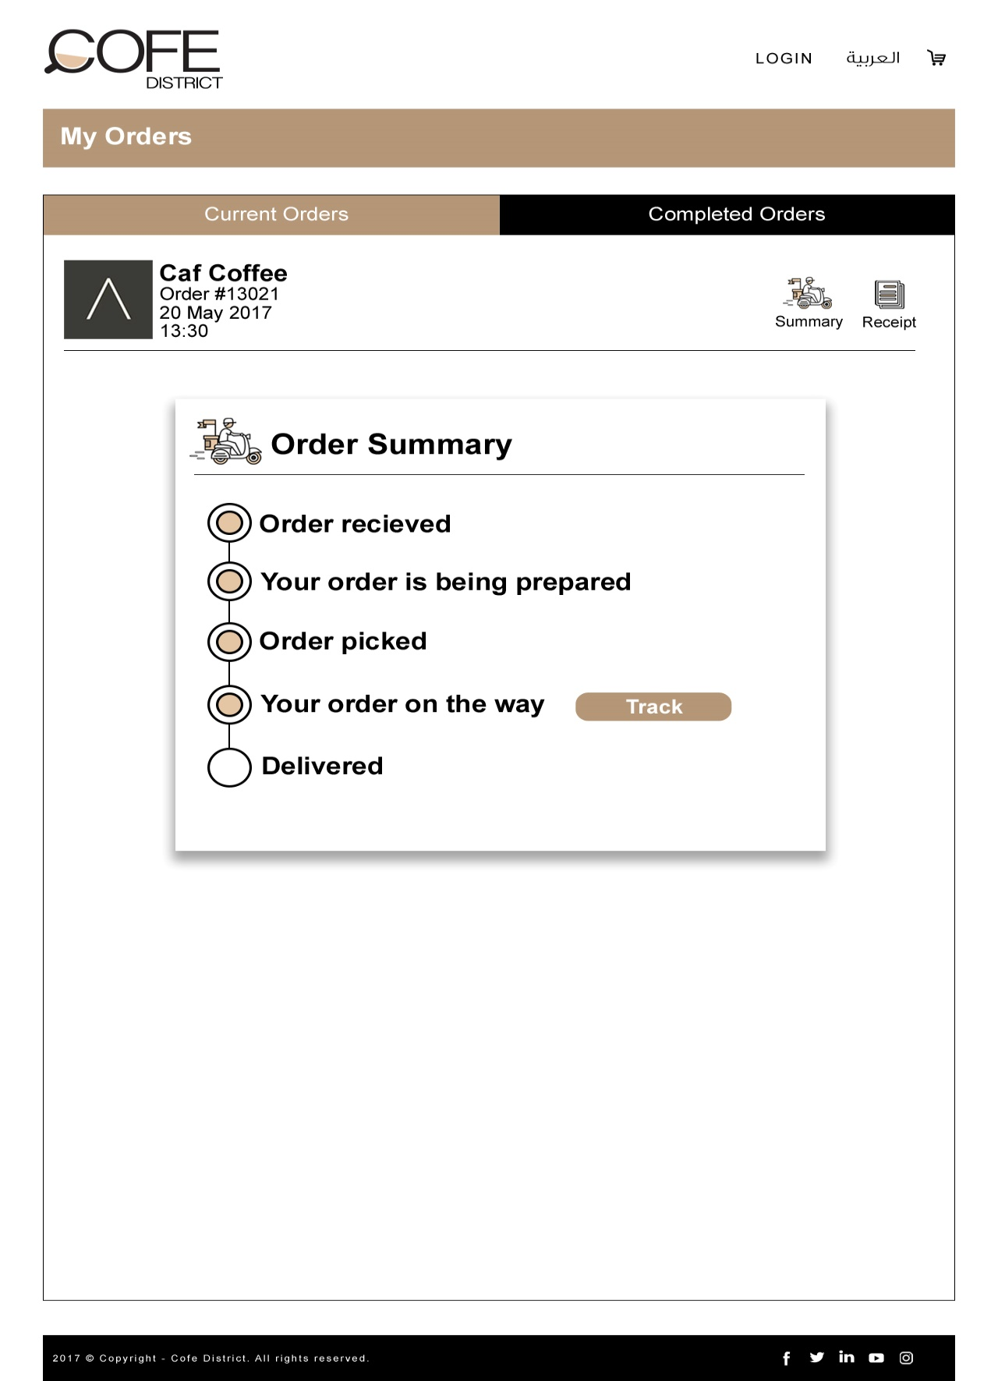

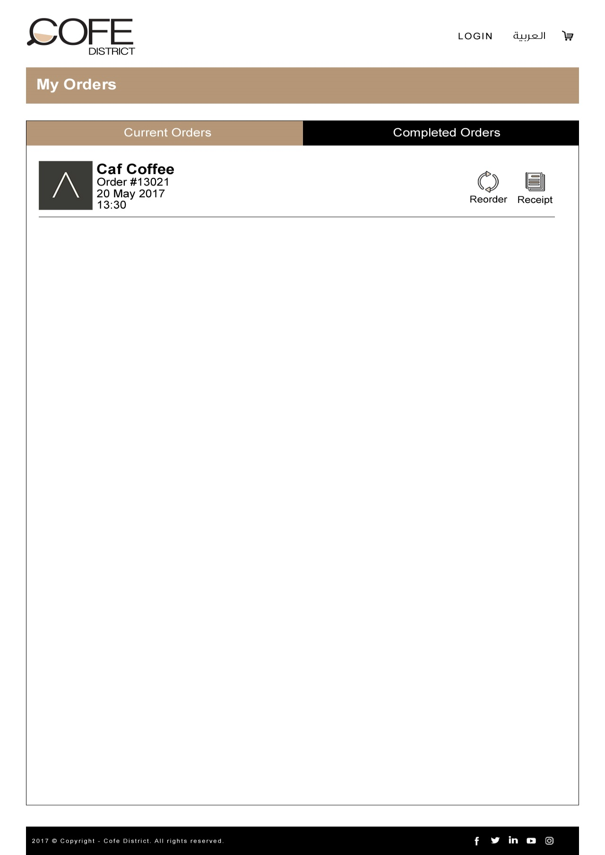

Change Password

This section allows the user to change his/her account password. For changing the password, the user needs to enter the below details

* + - * Current Password
      * New Password
      * Re-enter Password

When the user enter the above information and submit for password change, then the system will check the entered “Current Password” is correct or not. If it is wrong, the system will not allow the user to change his/her password and also will show the specific error message. The system will also validate the “New Password” and “Re-enter Password” values.

Forgot Password

This will allows customer to reset his account password if he/she ignored the password. By clicking on the “forgot password” link, the user will be redirected to a page where he/she needs to enter his/her email Id that is registered in the website.

The system will check the entered email id of the user is registered in the system or not. If not, the system will show a message to the user that the email id is not exists. If the email id is exist, then the system will send a password reset link to registered email Id and will show a message to the user that the link is sent to the email id.

This link will be for one time use and after the user reset his account password with the specific link, the link will be expired. The user can open the password reset link that he received in the email and then he can enter the below details to complete the password reset

* + - * New Password
      * Re-enter Password

After submitting these details, the password for his/her account will be updated and the user will be redirected to the login page of the website.

**Location History :**

This feature allows logged in customer to save the address locations that he/she received orders on it,

Location history should contains a list of address locations for the logged in customer on his own dashboard.

When a customer making an order, he/she use this feature to select one of these locations

**Re Order**

This feature allows the logged in customer to re order any orders from the order history page. Each order in the order history will have a button called “Buy it again”, this allows the customer to re order the selected order.

When the customer selects re order, the items in the selected order will be added to his/her cart. During re order when an item is not available or the selected quantity is not available for any item, the system will show an error message to the customer about the non-availability of the specific item. Then the customer can remove/manage the quantity of the item to proceed to re ordering.

The re ordering will add the items to the cart and the customer can add more items to cart in the normal way if he/she needs add more items other than the items in the re ordered order. After managing the items, the customer can proceed to checkout in the normal way.

**Direction Map:**

This allows driver users to use google maps for getting the directions of the client & Coffee Shop branch.

The driver can use maps to deliver the order then the driver can use it also to return back to the Coffee Shop branch.

**Offline Orders:**

This is a feature for the Coffee Shops to enable or disable offline orders. Coffee Shops can enable offline orders from the admin panel to receive orders from customers on closed time. The customers can only order from Coffee Shops that are opened or that Coffee Shops accepts offline orders.

The customers cannot order from Coffee Shops that are closed or the Coffee Shops that are closed and is not accepting offline orders.

Customer can order from a Coffee Shop that accept offline order and can select items even if the Coffee Shop is closed. While adding the items to cart, the system will notify the customer that he/she is ordering offline orders and it will be placed only on the next working hours of the Coffee Shop.

Customer should provide the following information when he/she is doing offline orders

1. Date of the delivery
2. Time of the delivery
3. Comments (If the customer wants to add any details)

When the customer order offline orders, the specific Coffee Shops will receive notifications in the dashboard as well as email notifications about the order with the above details.

Create New Account

When the user clicks on the “Create New Account” link in the login page or “Register” button from the website header, the user will be redirected to the “Customer Registration page”. This allows the non-registered users to create accounts in the Deera Coffee website.

1. **Customer Registration**

Deera Coffee website allows the non-registered users to create account in the Deera Coffee website as customer.

Users email id will be used to login to the website and so email id will be unique. So using one email id, the user can create only one account in Deera Coffee website.

There will be a form for the customers to create new account in the Deera Coffee website. The form will have the following details

* + - * Account Information
        + Email
        + Password
        + Re-enter Password
        + First Name
        + Last Name
        + Mobile Number
        + House Phone
      * Delivery Information
        + Address Name
        + Address Type (Apartment/House/Office)
        + Block (Optional)
        + Street
        + Avenue (Optional)
        + Building
        + Floor
        + Apartment Number
        + Mobile Number
        + Phone Number (Optional)
        + Additional Directions (Optional)
      * Personal Information
        + Gender (Male/Female)
        + Occupation

Professional Services

Self-employed/Owner

Other

Text box to enter other occupation details

* + - * “I have read and understand the Privacy & Policy and agree to the Terms of Use” – Check box
      * Submit

The user have to provide details for all the required fields of above and then he needs to accept the terms and conditions of Deera Coffee for creating new account.

There will be option to select the current location of the user in google map or user can select location manually from google map. This will fill the delivery area and then user can enter the other details.

After entering all the details and clicking on “Submit”, the system will check the email id is already exists in the system or not. If the email id is exists, the system will show error message to the user that the email id is already registered. If the email id is not existing or the user provide non registered email id, then the system will create new customer account for the user with the provided information.

After creating the account, the system will send email notification to the user in the registered email and the user will be redirected to the login page of the Deera Coffee website.

1. **Rate & Comment Service**

The registered users of the Deera Coffee website have the option to rate or put comments for any Coffee Shops and any coffee.

The rating of Coffee Shops and coffee can be done from all the listing sections and details pages.

The registered users can add comments from the Coffee Shop details page for Coffee Shops and dish details view for dish. When the user add any comments, it will not show the comment at the same time.

Whenever the user adds any comments for Coffee Shop or dish, it will be send to the Deera Coffee admin for review and approval. The comments will be displayed for the specific Coffee Shop or dish only when the Deera Coffee admin approves the comment.

1. **About Deera Coffee**

This page will have the details about the Deera Coffee website. There will be the following details in the page

* + - * Banner Image – Not changeable
      * Title
      * Detailed description about Deera Coffee

The title and detailed description of the page can be managed from the admin panel by the Deera Coffee Admin.

1. **Privacy Policy**

This page will have the privacy policy details of Deera Coffee website. There will be the following details in the page

* + - * Banner Image – Not changeable
      * Title
      * Privacy policy details

The title and privacy policy details of the page can be managed from the admin panel by the Deera Coffee Admin.

1. **Site Map**

This page will have the site structure of the website that will display the list of website pages, areas, cousins in a tree structure. All these sections will be linked with the specific detail pages in the website.

The content of the page will be static and Deera Coffee admin cannot edit the content from the admin panel.

1. **Terms & Conditions**

This page will have the details of the terms & conditions of the Deera Coffee website. There will be the following details in the page

* + - * Banner Image – Not changeable
      * Title
      * Terms & Conditions details

The title and Terms & Conditions details of the page can be managed from the admin panel by the Deera Coffee Admin.

1. **FAQ**

This will be a static page and so the content cannot be edited by the Deera Coffee admin. This page will have the list of frequently asked questions and answers.

1. **Contact Us**

This page will have contact form that allows the user to send email to the Deera Coffee admin to ask about any enquiries or information. The email will be forwarded to the Deera Coffee admin’s email and this email id can be managed from the admin panel by Deera Coffee admin.

There will be following fields in the contact form,

* + - * Name
      * Email
      * Phone Number
      * Comments

After submitting the form, the submitted details will be forwarded to Deera Coffee admin’s email and a confirmation email will be send to the contacted persons email id.

1. **Deera Coffee Admin Panel**

The Deera Coffee admin panel will be accessible by the Deera Coffee Admin, Coffee Shop Admin. The view of admin panel will be different for the specific users based upon the user roles.

There will be login page for the admin panel before accessing any administration pages. The admin users’ needs to enter the valid username and password for accessing the admin panel.

Deera Coffee Admin (Super Admin)

Deera Coffee admin have the full authority and access to the following functionalities of admin panel

* + - * Order Management
      * Coffee Shop Management
      * Area Management
      * User Management
      * Driver Management
      * Website Management
      * Reports Management
      * Resource String Management
      * Review Moderation
      * Home Banner Management
      * Content Management
      * New Coffee Shops Management
      * Coffee Shop Group Management
      * Pending Approvals
      * Edit Account

Order Management

This will be the default page of the admin panel when Deera Coffee admin is login to the system. This page allows the Deera Coffee admin to view the list of orders that are “Pending”, “Assigned”, “Rejected by Driver”, or “Delivered” in the system.

There will be the following filters available to view the order list

* + - * Coffee Shop Name
        + All
        + Coffee Shop list
      * User Type
        + All
        + Registered User
        + Guest User
      * Status
        + All
        + Pending
        + Assigned
        + Rejected by Driver
        + Delivered
      * Transaction Type
        + KNET
        + VISA/MasterCard
        + Cash on Delivery
        + All

These filters allows the Deera Coffee admin to view the list of orders with different criteria. There will be the following details for each order in the list

* + - * Transaction Id
      * Order Id
      * Email
      * User Type
        + Registered User
        + Guest User
      * Status
        + Pending
        + Assigned
        + Rejected by Driver
        + Delivered
      * Payment Mode
        + KNET
        + CASH
        + VISA/MasterCard
      * View More
        + Link to view full details of the order

Status details

*Pending*: - Order received by the Coffee Shop admin but still not assigned to any driver.

*Assigned*: - Order has assigned to driver by the Coffee Shop admin/Deera Coffee Admin.

*Rejected by Driver*: - Order delivery request has rejected by the assigned driver.

*Delivered*: - Order has delivered to the customer specified delivery location by the driver.

View More

This will show the full details about the order including transaction details, payment details, customer details, delivery location details and assigned/rejected driver details.

Assign to driver

The Deera Coffee admin can assign the order to any specific driver from this page using “Assign” button. When the admin clicks on the assign option, a popup will show with the list of drivers that are near to the Coffee Shop that has the delivery.

1. Administration Section

The administration section allows the following admin users to manage the different components in the Deera Coffee E-commerce website

* + - * Super Admin
      * Coffee Shop Admin

These users have different authorizations and privileges to the administration sections.

1. **Super Admin**

Super admin will be the master admin account in the Deera Coffee website. Deera Coffee admin will be the super admin for the system. The following sections can be managed by the super admin

* + - * Order Management
      * Coffee Shop Management
        + Add Coffee Shop
        + Search Coffee Shop

Status

Open

Closed

Busy

Hidden

Coffee Shop Name

* + - * + Coffee Shop List

Sort Order

Thumbnail Image & Title

Accepted payment types

Brach details

Number of branches

Number of open branches

Number of closed branches

Number of busy branches

Number of hidden branches

Actions

Delivery Menu

Branches

Status

Manage

Edit Coffee Shop

Edit details

Manage Drivers

Manage Branch

Manage Menu

Current Status (Open/Closed/Busy/Hidden)

* + - * New Coffee Shops
      * Area Management
      * User Management
      * Users Management
      * Resource Strings
      * Review Comments
      * Home Banner Management
      * Content Management
      * Notification Management
      * Reports

**Order Management**

Super admin can manage the orders for different Coffee Shops from this section. This orders will be listed in the page, and the super admin can use the following filters to view the filtered order lists

* + - * + Coffee Shop Name

All

List of Coffee Shops

* + - * + User Type

All

Registered Users

Guest Users

* + - * + Transaction Type

All

KNET

Cash On Delivery

VISA/MasterCard

* + - * + From Date
        + To Date
        + Status

The list of orders will be generated with respect to the filter options the Super admin have selected. The list will have the following details

* + - * + Transaction Id
        + Order Id
        + Email
        + User Type
        + Status
        + Payment Type
        + View Details
        + Assign To Driver/Reassign to driver

The list will have the above details and “View more” will show the full details of the order.

Assign to Driver/ Reassign to driver: - This will allow the Super admin to assign or re assign any specific order to a specific driver. For not assigned orders, this will display “Assign to driver” and after assigning the order to any driver will show option as “Reassign to driver”.

Clicking on the above option will show the below details to the Super admin

* + - * + Order summary
        + Delivery location in google map
        + Ordered branch details and location in google map
        + Drivers list who are near to the ordered branch (The driver who are nearest to the branch will be on the top of the list)

Clicking on the driver names in the list will show the following details in a popup

* + - * + Driver details
        + Current location of driver in google map
        + Drivers mobile battery status
        + Total orders delivered for today
        + Total orders in hand for today
        + History of orders
        + Assign/Reassign

History of orders: - The super admin can view the history of orders for the specific driver. There will be “from” and “to” date selection to view the delivered orders for the specific date.

The super admin can see the above details of the driver and then he can assign or reassign the order to the driver.

Super admin can assign Deera Coffee drivers or drivers of the specific Coffee Shops for delivering any order. Coffee Shops should pay extra payments to Deera Coffee if the order is assigning to Deera Coffee driver.

If the super admin assign an order to a driver, then the driver will be notified. Then the driver can accept/reject the assigned order. If the driver accepts the order, then the order delivery will be assigned to the specific driver.

If the driver rejects the order or the driver is not available then the Super admin can reassign the same order to another driver. In this case the first driver will be released from this order and the new driver will be assigned for this order.

**Coffee Shop Management**

This will allows the super admin to manage the Coffee Shops in the Deera Coffee website. There will be search option for the super admin to search for any specific Coffee Shops in the Deera Coffee website. Following are the search options available for the super admin

* + - * + Status

Open

Closed

Busy

Hidden

* + - * + Coffee Shop Name (English/Arabic)

Following sections can be managed from the Coffee Shop management

Create new Coffee Shops

This allows the super admin to create new Coffee Shops in the Deera Coffee website. The super admin can create unlimited number of Coffee Shops Deera Coffee website.

For creating Coffee Shops, the super admin have to provide detail for both English and Arabic. Following are the details for creating new Coffee Shops

* + - * + Coffee Shop Status
        + Coffee Shop Name (English)
        + Coffee Shop Name (Arabic)
        + Description (English)
        + Description (Arabic)
        + Summary (English)
        + Summary (Arabic)
        + URL
        + Coffee Shop Thumbnail
        + Payment Methods

KNET + Textbox for Commission Amount

COD + Textbox for Commission Amount

VISA/MasterCard + Textbox for Commission Amount

* + - * + Post Date Order (Number of days – for ordering in advance)
        + Commission Type

Percentage

Fixed

* + - * + Minimum Order Amount
        + Discount Type

Percentage

Fixed

* + - * + Discount
        + Enable/Disable push notifications

Above are the details that are required to create a new Coffee Shop in Deera Coffee website. After creating the Coffee Shop, super admin can manage the following details for the new Coffee Shop.

* + - * + Drivers
        + Branches
        + Delivery Menu

Edit Coffee Shop

Super admin can modify existing details of any specific Coffee Shop using “Edit Coffee Shop” option. Following are the details that the super admin can manage for each Coffee Shop

* + - * + Coffee Shop Status
        + Coffee Shop Name (English)
        + Coffee Shop Name (Arabic)
        + Description (English)
        + Description (Arabic)
        + Summary (English)
        + Summary (Arabic)
        + URL
        + Coffee Shop Thumbnail
        + Payment Methods

KNET + Textbox for Commission Amount

COD + Textbox for Commission Amount

VISA/MasterCard + Textbox for Commission Amount

* + - * + Post Date Order (Number of days – for ordering in advance)
        + Commission Type

Percentage

Fixed

* + - * + Minimum Order Amount
        + Discount Type

Percentage

Fixed

* + - * + Discount
        + Enable/Disable push notifications

From the edit Coffee Shop page, the super admin can also the following sections

* + - * + Drivers
        + Branches
        + Delivery Menu

Delivery Menu Management

This section allows the super admin to manage the delivery menu for any specific Coffee Shop. Following are the details that are required for adding/editing a delivery menu

* + - * + Menu Name (English)
        + Menu Name (Arabic)
        + Description (English)
        + Description (Arabic)
        + Status

Hide

Show

The food items will be added under any specific menu for the Coffee Shops. Status of the delivery menu will allow the super admin to show or hide the delivery menu from the Coffee Shop details page.

Super admin will have the option to edit/delete any existing delivery menu for any Coffee Shop.

Menu of a Coffee Shop will have the multiple numbers of sections. Each section will have multiple food items.

There will be “View full menu” and “View section” for menus in each Coffee Shop.

**View Full Menu**: - This will have the details of all the sections and all the food items under each section. This will have the following details

* + - * + Section A

Item 1

Name (English)

Price

Name (Arabic)

Thumbnail Image

Item 2

Name (English)

Price

Name (Arabic)

Thumbnail Image

Item 3

Name (English)

Price

Name (Arabic)

Thumbnail Image

* + - * + Section B

Item 4

Name (English)

Price

Name (Arabic)

Thumbnail Image

Item 5

Name (English)

Price

Name (Arabic)

Thumbnail Image

**View Section**: - This will show the list of sections that are added for a Coffee Shop menu. This list will have the following details

* + - * + Section Name (English)
        + Section Name (Arabic)
        + Status
        + Edit Section
        + View Menu Item

**Edit Section**: - Edit Section allows the user to edit the existing details of a specific section. Following details of a section can be edit by the super admin

* + - * + Section Name (English)
        + Section Name (Arabic)
        + Description (English)
        + Description (Arabic)
        + Status (Hide/Show)

**View Menu Item**: - This will show the list of menu items (food items) for the specific section. There will be a list of menu items for the specific section, and the details for each menu item in the list are as below

* + - * + Menu Item Name (English & Arabic)
        + Price
        + Status
        + Thumbnail
        + Edit Item
        + Category Choice – for adding special choice food items related to the selected menu item

Edit any specific menu item will allow the super admin to edit the following detail of the menu item

* + - * + Menu Name (English)
        + Menu Name (Arabic)
        + Description (English)
        + Description (Arabic)
        + Price
        + Discount
        + Thumbnail
        + Available From
        + Available To
        + Menu Section
        + Status

Super admin can modify any details of the above and can save the details.

There will be “Add Menu item” option for the super admin to create new menu items for any specific sections. Following are the details that are needed for creating a new menu item

* + - * + Menu Name (English)
        + Menu Name (Arabic)
        + Description (English)
        + Description (Arabic)
        + Price
        + Discount
        + Thumbnail
        + Available From
        + Available To
        + Menu Section
        + Status

**Category Choice**: - This will allows the super admin to manage the special choices for the specific menu item. When a menu item have the category choices, then these category choice items will be displayed along with the menu item in the menu details page. The category choice item will have the following

* + - * + Create category choice
        + List of category choices

Edit

Choice

*Create category choice* will allow the super admin to create new category choice for the menu item. Following detail are required for creating new category choice

* + - * + Name (English)
        + Name (Arabic)
        + Minimum items – Minimum order quantity
        + Maximum items – Maximum order quantity

*Editing category choice* allows the super admin to modify any existing category choices, following details can be modified

* + - * + Name (English)
        + Name (Arabic)
        + Minimum items – Minimum order quantity
        + Maximum items – Maximum order quantity

Choices will allows the super admin to manage the food item choices for the specific category choice. Following will be in the choices

* + - * + Add Menu Item Choice
        + List of choices

Name

Price

Available (From and To)

Thumbnail Image

Edit Item

For creating choice for any category choice, following detail are needed

* + - * + Name(English)
        + Name(Arabic)
        + Description(English)
        + Description(Arabic)
        + Status
        + Price
        + Discount
        + Thumbnail
        + Available From
        + Available To

While editing any category choice, following details can be managed by the super admin

* + - * + Name(English)
        + Name(Arabic)
        + Description(English)
        + Description(Arabic)
        + Status
        + Price
        + Discount
        + Thumbnail
        + Available From
        + Available To

There will be option “Add Section” for the super admin to create new sections for the menu in the view section page. Super admin can create new section with providing the following details

* + - * + Section Name (English)
        + Section Name (Arabic)
        + Description (English)
        + Description (Arabic)
        + Status (Hide/Show)

Branches Management

This allows the super admin to manage the braches for any specific Coffee Shop. Super admin can create braches from this page, using “Add Branch” link. For adding a branch for a specific Coffee Shop, super admin have to provide the following details

* + - * + Area Name

List of areas

* + - * + Description(English)
        + Description(Arabic)
        + Phone
        + Fax
        + Fax Backup
        + Routing Method

Fax

Application

Phone

Email

* + - * + Location selector using google map (Will set the latitude and longitude details from google map)

Latitude

Longitude

Super admin can create branches for Coffee Shops using the above details and there will be location selection option for the super admin to select the exact location of the branch on google map. Whenever the super admin selects the google map location, the latitude and longitude details will be fetched from the google map and the super admin can save the new branch details.

There will be list of branches for the Coffee Shop in the branch management page and it will have the following details of each branch

* + - * + Branch Id
        + Branch Name

Number of covering areas

Number of open branches

Number of closed branches

Number of busy branches

* + - * + Status (Hide/Show)
        + Edit Branch
        + Delete

**Status**: - The super admin can set hide/show status for any specific branch.

Edit Branch

This will allows the super admin to edit the following details of any specific Coffee Shop branch

* + - * + Area Name

List of areas

* + - * + Description(English)
        + Description(Arabic)
        + Phone
        + Fax
        + Fax Backup
        + Routing Method

Fax

Application

Phone

Email

* + - * + Location selector using google map (Will set the latitude and longitude details from google map)

Latitude

Longitude

Super admin can edit the above details of branches. There will be location selection option for the super admin to select the exact location of the branch on google map. Whenever the super admin selects the google map location, the latitude and longitude details will be fetched from the google map and the super admin can update the branch details.

**New Coffee Shops**

This page will show the list of Coffee Shops that recently added in the Deera Coffee website. The Coffee Shops that added recently and lesser than one month will be displayed in this page.

The functionalities and details will be same as “Coffee Shop Management”.

**Area Management**

This page allows the super admin to manage the areas for the Deera Coffee website. The super admin can add/edit or delete any specific area.

Following are the details required for add/edit any area

* + - * + Area Name (English)
        + Area Name (Arabic)

This page will also show the list of areas that are already exist in the Deera Coffee website. Following are the details displayed in the list

* + - * + Area Name (English)
        + Area Name (Arabic)

**User Management**

This page allows the super admin to manage the user accounts for Deera Coffee website and mobile applications.

Super admin can manage following types of user roles

* + - Super Admin
    - Coffee Shop Admin
    - Driver
    - Customer

Following are the details of each user role

Super Admin

* + - Admin with full control over the Deera Coffee admin panel and mobile applications.
    - These admins will have full privileges in the Deera Coffee admin panel and mobile applications.
    - These admins can manage orders, Coffee Shops, pages, areas, admin users, registered users etc.
    - These admins will be for Deera Coffee.

Coffee Shop Admin

* + - These admins are the admin users for specific Coffee Shops.
    - Multiple Coffee Shop admins can be assigned for a Coffee Shop.
    - Multiple Coffee Shops can be assigned to a Coffee Shop admin.
    - Coffee Shop admin will only have access to the specific Coffee Shop and the orders specific to the Coffee Shop.
    - Super admin will create and assign Coffee Shop admins for different Coffee Shops.

Driver

* + - These users are for delivering the orders of customers from the specific Coffee Shops branches.
    - Super admin can create drivers for Deera Coffee and also for the Coffee Shops separately.
    - Driver users are for mobile applications.
    - Coffee Shops can use their drivers and also Deera Coffee drivers for delivering any order.
    - Coffee Shops should pay extra payments for assigning Deera Coffee drivers.
    - There will be option for the super admin to select the Coffee Shop names, if the driver is creating for Coffee Shops.

Customer

* + - These are the registered users from website and mobile applications, who will order and buy foods from different Coffee Shops.

Super admin will have the following sections in the admin user management

* + - * + Create Admin
        + Search Admin
        + List of Admin Users

Super admin can create admin users for any of the above user roles. For creating admins, super admin have to provide the following details

Super Admin

* + - * User Name
      * Password
      * Confirm Password
      * Email
      * First Name
      * Last Name
      * Mobile Number
      * User Role

Coffee Shop Admin

* + - * User Name
      * Password
      * Confirm Password
      * Email
      * First Name
      * Last Name
      * Mobile Number
      * User Role
      * Coffee Shops

List of Coffee Shops to assign

Driver

This drivers will be drivers for Deera Coffee, and for creating drivers for Coffee Shops the super admin needs to add drivers in the Coffee Shop/new Coffee Shop management pages.

* + - * User Name
      * Password
      * Confirm Password
      * Email
      * First Name
      * Last Name
      * Mobile Number
      * Driving License Number
      * Civil Id Number
      * User Role
      * Is Deera Coffee Driver? (Checkbox selection if the driver is creating for Deera Coffee)
      * Coffee Shops (Only needs to select if the driver is creating for Coffee Shops)

List of Coffee Shops

Customer

* + - * User Name
      * Password
      * Confirm Password
      * Email
      * First Name
      * Last Name
      * Mobile Number
      * User Role

Super admin have the search option to search for any specific admin user. Following are the filters that are available

* + - * + User Role
        + User Name
        + First Name
        + Last Name
        + Mobile Number
        + Email

Using the above filters, super admin can search for any specific users. This will show the list of admin users with respect to the searched criteria. Following are the details available in the list of users

* + - * + Email Id
        + First Name
        + Last Name
        + Edit
        + Change Password
        + Block/Unblock
        + Delete

Edit: - This allow the super admin to change and update any information related to a specific user.

Change Password: - This allows the super admin to change password for a specific user’s account. For changing password, super admin have to provide the below details

* + - * + New Password
        + Confirm Password

Block/Unblock: - This allows the super admin block/unblock any user to access Deera Coffee admin panel/mobile applications.

Delete: - This allows the super admin to delete any specific user account for Deera Coffee admin panel/mobile applications.

**Resource Strings**

This section allows the super admin to manage the English/Arabic translations for different pages.

There will be a list of words or contents of pages, super admin can manage the value for both English and Arabic.

Following are the details available in the resource strings page

* + - * + Search
        + List of strings

Id

Name

Value

Last Modified Date

Edit/Delete

Search: - This allows the super admin to search for a specific word. During search, super admin have to select the language (English/Arabic). This will show the list of strings that are already added to the system.

Edit: - This will allow the super admin to edit value of any specific content for a page. Super admin can modify and click “Update” for completing the update or he can cancel the operation by clicking “Cancel”.

Delete: - This will allow the super admin to delete a resource string entry from the system.

**Review Comments**

Form this section, super admin can manage the comments that are submitted by the customers for each Coffee Shop. There will be a list of comments for different Coffee Shops in the Deera Coffee website.

Following are the details for the review comments page

* + - * + Search

From Date

To Date

Sort By

All

Unapproved

Approved

Deleted

List of comments

Coffee Shop Name

User Name

Comments

The search section allows the super admin to search for the comments for a specific period of time or for a specific status of the comment.

By default, the comments list show the unapproved comments. This list will be sorted with respect to the date of the comments. The latest comments will be placed on top of the list.

While the super admin search for comments for a specific time interval, the list will show the comments for the specific time interval and also with respect to the selected status of the comments.

There will option for the super admin to approve comments from unapproved list. Only approved comments will be displayed in the comments section of the specific Coffee Shops.

Super admin can also delete any specific comments that are under the status “Approved” or “Unapproved”. Whenever super admin deletes any comments from this page, the same comments will be removed from the specific Coffee Shop’s details page.

**Home Banner Management**

This allows the super admin to manage the home page banner images. There will be list of banner images that are already added in the system. Super admin can manage the following for home banners

* + - * + Add New Banner
        + List of Banners

Name

Sort Order

Banner Image

URL

Publish Status (Published/Unpublished)

* + - * + Edit/Delete

Add New Banner: - This allows the super admin to create new banner images for Deera Coffee website. For adding new banners, super admin have to provide the following details

* + - * + English Tab

Name

Sort Order

Banner Image

URL

* + - * + Arabic Tab

Name

Sort Order

Banner Image

URL

* + - * + Publish Status (Published/Unpublished)

There will be two tabs for the each banner, one tab is to manage English home page related banner details and other is to manage Arabic home page related banner details.

For saving a banner image, the super admin have to provide the details in both English and Arabic tabs.

Edit Banner: - This allows the super admin to modify and update banner images that are already exists in the Deera Coffee website. For updating the banner image, super admin have to provide the following details

* + - * + English Tab

Name

Sort Order

Banner Image

URL - linked with the banner image

* + - * + Arabic Tab

Name

Sort Order

Banner Image

URL - linked with the banner image

* + - * + Publish Status (Published/Unpublished)

There will be two tabs for the each banner, one tab is to manage English home page related banner details and other is to manage Arabic home page related banner details.

For saving a banner image, the super admin have to provide the details in both English and Arabic tabs.

Delete: - This allows the super admin to delete any specific home page banner that is already existing in the Deera Coffee website.

Only published banner images will be displayed in the home page of the website.

**Content Management**

This allows the super admin to manage the static pages content of Deera Coffee website. This page will have a list of page names and the super admin can edit any specific page names from the list.

When clicking on the “Edit” will show the following details of the specific page

* + - * + Page Name
        + Language

English

Arabic

* + - * + Content (WYSIWYG Editor)
        + Update

Super admin can select any specific language (English/Arabic) from the language list, and then the content will be changed to the language selected.

After selecting the language, the super admin can change/modify the content in the WYSIWYG editor and he can update the content for the specific language using “Update” button.

**Notification Management**

This section allows the super admin to manage the push notifications for the mobile applications. Super admin can create notification messages and can send to users who all installed the Deera Coffee mobile applications.

Following are the details that required for creating notification messages

* + - * + Message (English)
        + Message (Arabic)

There will resend option for already sent messages, super admin can edit the message then he can update and send the message again.

**Reports**

This page allows the super admin to view different kinds of reports for Deera Coffee website. Super admin can view and export the reports for the system.

Super admin can export the reports to both excel and pdf documents. Following are some of the list of reports available in the system

* + - * + Best Coffee Shop
        + Customer Favorite Menu Item
        + Menu Item Rating
        + Most Selling coffee
        + Coffee Shop Rating
        + Yearly Sales
        + Monthly Sales
        + Daily Sales
        + Cancelled
        + Admin Users
        + Customers
        + Drivers Assigned Orders

**Edit Account**

This section allows the super admin to manage the following details for his account

* + - * + First Name
        + Last Name
        + Mobile Number
        + Password

For changing the password, super admin have to provide the following details

* + - * + Password
        + Confirm Password

1. **Coffee Shop Admin**

Coffee Shop admins are the admin users, only for any or some Coffee Shops. These type of admins can login to the Deera Coffee admin panel for managing the following details for the Coffee Shops that they have assigned with

* + - * + Order Management
        + Coffee Shop Management
        + Review
        + Reports

**Order Management**

Coffee Shop admin can manage the orders for different Coffee Shops that he/she have assigned with. These orders will be listed in order management page, and the Coffee Shop admin can use the following filters to view the filtered order lists

* + - * + Order Number
        + Mobile Number
        + Status

List of status of order

* + - * + From Date
        + To Date

The list of orders will be generated with respect to the filter options the Coffee Shop admin have selected. The list will have the following details

* + - * + Order Id
        + Coffee Shop Name
        + Customer Name
        + Mobile Number
        + Payment Mode
        + Amount
        + Date
        + Email
        + User Type
        + Status
        + View Details
        + Assign To Driver/Reassign to driver

The list will have the above details and “View Details” will show the full details of the order.

There will be “Refresh” option for the Coffee Shop admin to refresh the order list, so that he/she can view the latest orders for the Coffee Shops that he/she assigned with.

Assign to Driver/ Reassign to driver: - This will allow the Coffee Shop admin to assign or re assign any specific order to a specific driver. For not assigned orders, this will display “Assign to driver” and after assigning the order to any driver will show option as “Reassign to driver”.

Clicking on the above option will show the below details to the Coffee Shop admin

* + - * + Order summary
        + Delivery location in google map
        + Ordered branch details and location in google map
        + Drivers list who are near to the ordered branch (The driver who are nearest to the branch will be on the top of the list)
        + These drivers list will only show the drivers that are assigned for the specific Coffee Shops of the Coffee Shop admin and the drivers for Deera Coffee also.

Clicking on the driver names in the list will show the following details in a popup

* + - * + Driver details
        + Details of drivers Coffee Shop/Deera Coffee driver
        + Current location of driver in google map
        + Drivers mobile battery status
        + Total orders delivered for today
        + Total orders in hand for today
        + History of orders
        + Assign/Reassign

History of orders: - The Coffee Shop admin can view the history of orders for the specific driver. There will be “from” and “to” date selection to view the delivered orders for the specific date.

The Coffee Shop admin can see the above details of the driver and then he can assign or reassign the order to the driver.

Coffee Shops can use their drivers and also Deera Coffee drivers for delivering any order. Coffee Shops should pay extra payments to Deera Coffee if they are assigning Deera Coffee drivers for delivering orders.

If the Coffee Shop admin assign an order to a driver, then the driver will be notified. Then the driver can accept/reject the assigned order. If the driver accepts the order, then the order delivery will be assigned to the specific driver.

If the driver rejects the order or the driver is not available then the Coffee Shop admin can reassign the same order to another driver from the list. In this case the first driver will be released from this order and the new driver will be assigned for this order.

In orders table,

Admins can view the status of user, if a user is (registered, guest).

The system allows guest users to order from the website and mobile app for a maximum number of orders.

The maximum number of orders should be manageable by admins.

The customers will receive the sender ID which it’s inserted in the admin panel.

**Map Dashboard:**

This will allows Coffee Shops admin to view a map of Kuwait cities, each city will have a number of orders, and this map will display a number of orders in each city.

The number of orders in each city should increasing when a new orders have been submitted.

**Coffee Shop Management**

This will allows the Coffee Shop admin to manage the Coffee Shops that he/she assigned with in the Deera Coffee website. There will be search option for the Coffee Shop admin to search for any specific Coffee Shops (only assigned) in the Deera Coffee website. Following are the search options available for the Coffee Shop admin

* + - * + Status

Open

Closed

Busy

Hidden

* + - * + Coffee Shop Name (English/Arabic)
        + Sender ID

Following sections can be managed from the Coffee Shop management

Edit Coffee Shop

Coffee Shop admin can modify existing details of any specific Coffee Shop using “Edit Coffee Shop” option. Following are the details that the Coffee Shop admin can manage for each Coffee Shop

* + - * + Coffee Shop Status

For each Coffee Shop, the Coffee Shop admin can manage the following sections

* + - * + Status
        + Branches
        + Delivery Menu
* On “**Offline Orders** “option, can book order by date/time
  + Can make option for each Coffee Shop to enable / disable the offline option

***By Offline Orders, do you mean the downtime of Coffee Shops?***

***Suppose if a Coffee Shop X operates from 9:00 to 21:00 and a customer makes an order at 22:00, he will be notified that his order will be processed only at the next working hours which will be on next day at 9:00.***

***“Offline orders” will be a service that can Coffee Shop enable / disable it, if enable then customer can book his order in (date and time), for your example Coffee Shop X “has offline orders service” and operates from 09:00 to 21:00, and customer makes order at 22:00, customer will determine his order to be delivered by (date and time: 16/12/2016 and 08:00 am)***

**Customer can type date and time to deliver, and can add comments in text box**

Delivery Menu Management

This section allows the Coffee Shop admin to manage the delivery menu for any specific Coffee Shop. Following are the details that are required for adding/editing a delivery menu

* + - * + Menu Name (English)
        + Menu Name (Arabic)
        + Description (English)
        + Description (Arabic)
        + Status

Hide

Show

The food items will be added under any specific menu for the Coffee Shops. Status of the delivery menu will allow the Coffee Shop admin to show or hide the delivery menu from the Coffee Shop details page.

Coffee Shop admin will have the option to edit/delete any existing delivery menu for any Coffee Shop.

Menu of a Coffee Shop will have the multiple numbers of sections. Each section will have multiple food items.

There will be “View full menu” and “View section” for menus in each Coffee Shop.

**View Full Menu**: - This will have the details of all the sections and all the food items under each section. This will have the following details

* + - * + Section A

Item 1

Name (English)

Price

Name (Arabic)

Thumbnail Image

Item 2

Name (English)

Price

Name (Arabic)

Thumbnail Image

Item 3

Name (English)

Price

Name (Arabic)

Thumbnail Image

* + - * + Section B

Item 4

Name (English)

Price

Name (Arabic)

Thumbnail Image

Item 5

Name (English)

Price

Name (Arabic)

Thumbnail Image

**View Section**: - This will show the list of sections that are added for a Coffee Shop menu. This list will have the following details

* + - * + Section Name (English)
        + Section Name (Arabic)
        + Status
        + Edit Section
        + View Menu Item

**Edit Section**: - Edit Section allows the Coffee Shop admin to edit the existing details of a specific section. Following details of a section can be edited by the Coffee Shop admin

* + - * + Section Name (English)
        + Section Name (Arabic)
        + Description (English)
        + Description (Arabic)
        + Status (Hide/Show)

**View Menu Item**: - This will show the list of menu items (food items) for the specific section. There will be a list of menu items for the specific section, and the details for each menu item in the list are as below

* + - * + Menu Item Name (English & Arabic)
        + Price
        + Status
        + Thumbnail
        + Edit Item
        + Category Choice – for adding special choice food items related to the selected menu item

Edit any specific menu item will allow the Coffee Shop admin to edit the following detail of the menu item

* + - * + Menu Name (English)
        + Menu Name (Arabic)
        + Description (English)
        + Description (Arabic)
        + Price
        + Discount
        + Thumbnail
        + Available From
        + Available To
        + Menu Section
        + Status

Coffee Shop admin can modify any details of the above and can save the details.

There will be “Add Menu item” option for the Coffee Shop admin to create new menu items for any specific sections. Following are the details that are needed for creating a new menu item

* + - * + Menu Name (English)
        + Menu Name (Arabic)
        + Description (English)
        + Description (Arabic)
        + Price
        + Discount
        + Thumbnail
        + Available From
        + Available To
        + Menu Section
        + Status

**Category Choice**: - This will allows the Coffee Shop admin to manage the special choices for the specific menu item. When a menu item have the category choices, then these category choice items will be displayed along with the menu item in the menu details page. The category choice item will have the following

* + - * + Create category choice
        + List of category choices

Edit

Choice

*Create category choice* will allow the Coffee Shop admin to create new category choice for the menu item. Following detail are required for creating new category choice

* + - * + Name (English)
        + Name (Arabic)
        + Minimum items – Minimum order quantity
        + Maximum items – Maximum order quantity

*Editing category choice* allows the Coffee Shop admin to modify any existing category choices, following details can be modified

* + - * + Name (English)
        + Name (Arabic)
        + Minimum items – Minimum order quantity
        + Maximum items – Maximum order quantity

Choices will allows the Coffee Shop admin to manage the food item choices for the specific category choice. Following will be in the choices

* + - * + Add Menu Item Choice
        + List of choices

Name

Price

Available (From and To)

Thumbnail Image

Edit Item

For creating choice for any category choice, following detail are needed

* + - * + Name(English)
        + Name(Arabic)
        + Description(English)
        + Description(Arabic)
        + Status
        + Price
        + Discount
        + Thumbnail
        + Available From
        + Available To

While editing any category choice, following details can be managed by the Coffee Shop admin

* + - * + Name(English)
        + Name(Arabic)
        + Description(English)
        + Description(Arabic)
        + Status
        + Price
        + Discount
        + Thumbnail
        + Available From
        + Available To

There will be option “Add Section” for the Coffee Shop admin to create new sections for the menu in the view section page. Coffee Shop admin can create new section with providing the following details

* + - * + Section Name (English)
        + Section Name (Arabic)
        + Description (English)
        + Description (Arabic)
        + Status (Hide/Show)

Branches Management

This allows the Coffee Shop admin to manage the braches for any specific Coffee Shop. Coffee Shop admin can create braches from this page, using “Add Branch” link. For adding a branch for a specific Coffee Shop, Coffee Shop admin have to provide the following details

* + - * + Description(English)
        + Description(Arabic)
        + Phone
        + Fax
        + Fax Backup
        + Routing Method

Fax

Application

Phone

Email

* + - * + Location selector using google map (Will set the latitude and longitude details from google map)

Latitude

Longitude

Coffee Shop admin can create branches for Coffee Shops using the above details and there will be location selection option for the Coffee Shop admin to select the exact location of the branch on google map. Whenever the Coffee Shop admin selects the google map location, the latitude and longitude details will be fetched from the google map and the Coffee Shop admin can save the new branch details.

There will be list of branches for the Coffee Shop in the branch management page and it will have the following details of each branch

* + - * + Branch Id
        + Branch Name

Number of covering areas

Number of open branches

Number of closed branches

Number of busy branches

* + - * + Status (Hide/Show)
        + Edit Branch
        + Delete

**Status**: - The Coffee Shop admin can set hide/show status for any specific branch.

Edit Branch

This will allows the Coffee Shop admin to edit the following details of any specific Coffee Shop branch

* + - * + Description(English)
        + Description(Arabic)
        + Phone
        + Fax
        + Fax Backup
        + Routing Method

Fax

Application

Phone

Email

* + - * + Location selector using google map (Will set the latitude and longitude details from google map)

Latitude

Longitude

Coffee Shop admin can edit the above details of branches. There will be location selection option for the Coffee Shop admin to select the exact location of the branch on google map. Whenever the Coffee Shop admin selects the google map location, the latitude and longitude details will be fetched from the google map and the Coffee Shop admin can update the branch details.

**Review**

This page will show the list of approved comments from different customers for the Coffee Shop admins Coffee Shops.

Coffee Shop admin can view the list of comments, and he can also delete any specific comments for his/her assigned Coffee Shops.

Following are the details of comments that the page have

* + - * + Id
        + Coffee Shop Id
        + Coffee Shop Name
        + Comment
        + Delete

**Reports**

Coffee Shop admin can view the different kinds of reports that are only related to his/her assigned Coffee Shops.

Following are some of the reports that are available for the Coffee Shop admin

* + - * + Areas Covered
        + Menu Item Rating
        + Most Selling coffee
        + Sales By Area
        + Yearly Sales
        + Monthly Sales
        + Daily Sales
        + Cancelled
        + Drivers Assigned Orders

Coffee Shop admins can view and export the above different kinds of reports. There will be option for the Coffee Shop admin to export the report to both excel and pdf documents.

1. COMMON FUNCTIONALITIES

The following are the common functionalities or the Deera Coffee website

**Email Notification**

* There will be email notifications from the system on customer registration, forget password and reset password for customers.
* The customer will also receive the email notifications while they order any food items or their orders are processed to different status in the system.
* Whenever the customer place any order, authorized admins process/assign orders to drivers, drivers accept/reject order delivery, drivers completes order delivery the specific customers, admins, super admin, drivers will get email notifications.
* These email notifications will be in an email template that is matching with the Deera Coffee website theme.
* Email notifications will be sent using Deera Coffee SMTP, and so Deera Coffee will provide their SMTP details during development phase.

**Audit Track**

* There will be audit track for each admins activities in the Deera Coffee admin panel. This will includes the activities of Super admins, Coffee Shop admins and Call center users.
* The system will track the following details for each action they are performing in the system
* Date
* Action
* User Name
* User Role
* Description

**Language**

* Deera Coffee website and customer profile pages will be in both English and Arabic.
* Administration sections will be only in English
* Admin will have the option to manage the English & Arabic contents of pages, Coffee Shop and areas details from the admin panel.

# Approval

The undersigned acknowledge they have reviewed the **Deera Coffee** Functional Documentation document and agree with the approach it presents. Any changes to this Requirements Definition will be coordinated with and approved by the undersigned or their designated representatives.

|  |  |  |  |
| --- | --- | --- | --- |
| Signature: |  | Date: |  |
| Name: |  |  |  |
| Title: |  |  |  |
| Role: |  |  |  |

|  |  |  |  |
| --- | --- | --- | --- |
| Signature: |  | Date: |  |
| Name: |  |  |  |
| Title: |  |  |  |
| Role: |  |  |  |